Joyous festivities in Warsaw’s Old Town! The second edition
of Warsaw’s Old Town birthday celebration will begin on 19 July!

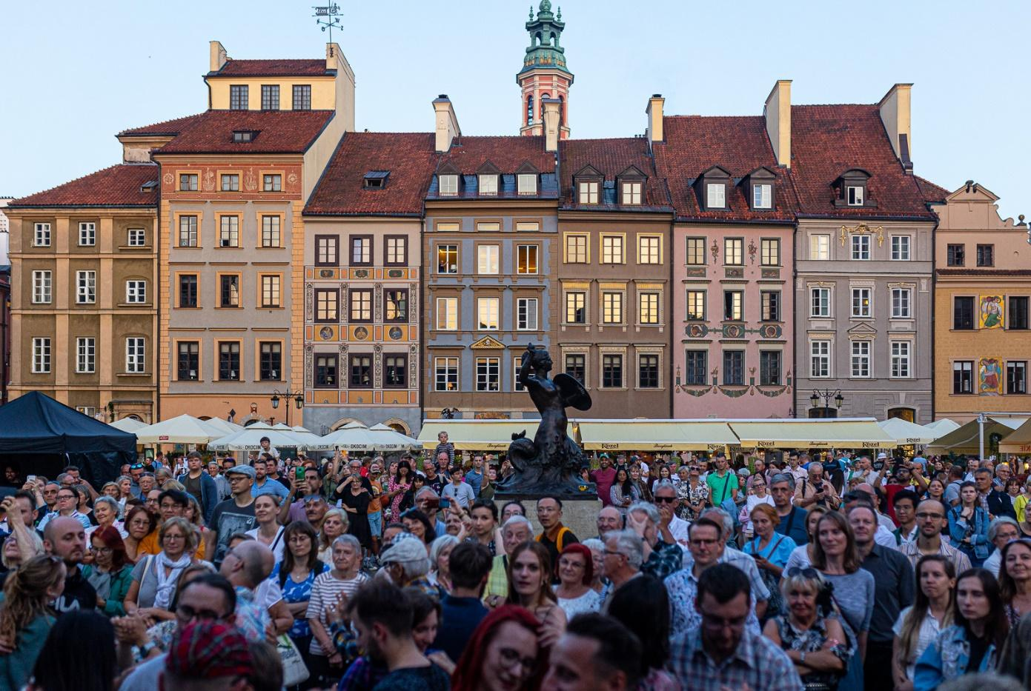
Warsaw’s Old Town and its vicinity, 19–21 July 2024
70th birthday of Starówka (Warsaw’s Old Town). Photo: Tomasz Kaczor
For three days in July, the Old Town—Starówka—will become Warsaw’s cultural centre. On the occasion of its 71st birthday, 40 institutions organize nearly 100 events, including a concert of the cult Molesta Ewenement group, Aga Zaryan Quintet concert as part of the 30th Jazz in Starówka International Outdoor Festival, dance party in the Old Town Market Square or a multicultural breakfast at the Common Table. The residents of Warsaw will have the opportunity to take part in walks, workshops, guided tours and even a tour of Warsaw’s art studios. The celebration will last from 19 to 21 July. For detailed program of events and an interactive map of the Old Town, please go to: www.grupastarowka.pl.
The pretext for organizing the festivities last year was the 70th anniversary of the reconstruction of the Old Town Market Square which, along with some of the Old Town streets, was opened for use exactly on 22 July 1953. The success of the Old Town’s 70th birthday means that the event has a chance to become a permanent fixture in the calendar of major Warsaw events.
“Last year’s unexpectedly high attendance at the Old Town’s birthday celebration made us realize that the residents of Warsaw need such an event. Crowds of Varsovians had the opportunity to see the rich and diverse cultural offer proposed by the institutions that operate in Starówka on a daily basis. We are very pleased that the energy generated last year through the collaboration of dozens of places has not been lost. We continue to work together as the Starówka Group—an informal network of Old Town institutions—and we return this year with even greater impetus. New places have joined us, and the program of events for the July weekend looks truly impressive,” says Karolina Ziębińska, director of the Museum of Warsaw which coordinates the collaboration of all the institutions involved and the anniversary organization.
This year, the festivities will be held on 19–21 July. Almost 100 events have been planned for the three days: concerts, walks, art workshops, guided tours, urban games, meetings, exhibitions, dance parties and a multicultural breakfast. The program includes, among others, a concert by the cult Molesta Ewenement group, commemoration of the 50th anniversary of installing the castle clock on the Clock Tower of the Royal Castle, or a concert by Aga Zaryan Quintet as part of the 30th Jazz in Starówka International Outdoor Festival.
Already at 5PM on Friday, 19 July, we invite you to a launch of the 71st birthday of Starówka. Czessband with Cała Praga Śpiewa senior band will perform, and an hour later the highlight of the evening—Molesta Ewenement, a legendary Polish hip-hop band. Czessband is a Warsaw-based group whose repertoire is based on beautiful Balkan and Hungarian tunes, and on a plethora of splendid Warsaw oldies goldies. Molesta Ewenement, a hip-hop music band formed in 1995, is considered one of the pioneers of the street rap genre in Poland.
On Saturday, 20 July, you will have a chance to listen to a lecture about the reconstruction of the Old Town. The Ukrainian House invites you to Time Travel: Discovering the Heritage of Warsaw’s Old Town. A lesson for adults in Ukrainian will uncover the secrets of the architecture, events, and biographies of the individuals who shaped the character of Warsaw’s Starówka. Saturday is also a good day to see one of the many exhibitions or participate in guided tours, for example, at the Association of Art Historians or the Heritage Interpretation Centre. There, at 10AM, a Story of Reconstructed Warsaw is planned—a tour for people with intellectual disabilities, and two hours later another tour for people with impaired hearing, with translation into Polish Sign Language. In the evening, we invite you to a concert by Aga Zaryan Quintet at the 30th Jazz na Starówce International Outdoor Jazz Festival. Aga Zaryan is the first Polish artist to release albums for the legendary New York-based Blue Note Records label and one of the best Polish jazz vocalists. She has gained the acclaim of audiences from Tokyo to New York. In July, it is Warsaw’s turn to enjoy her enormous talent!
You can begin Sunday, 21 July, by joining a multicultural breakfast as part of the series Intangible Warsaw: Breakfasts with New Warsaw Songs. A Latin-style breakfast will be served at the Common Table standing in front of the Museum of Warsaw’s main seat. The breakfast will be hosted by José Torres, a Cuban-Polish musician, percussion virtuoso and initiator of the first salsa orchestra, Jose Torres y Salsa Tropical. Sunday also offers many attractions for the youngest visitors. At 12 noon, the Museum of Literature invites you to Muzyczne podróże Pchły Szachrajki [Musical Travels of Flea Named Szachrajka] – an interactive performance for children aged 4-10. The performance is based on the texts of classic Polish children’s poets Jan Brzechwa and Julian Tuwim. On Sunday, you can also visit art studios under the care of the municipal Conservation Officer, or listen to numerous concerts. Those who enjoy discovering secrets should listen to the lectures and join in the walks. The Old Town will reveal usually inaccessible nooks and corners, such as closed courtyards and basements. Birdwatching walk with Staszek Łubieński is yet another interesting option. Participants will listen about the bird species flying around the Old Town and will learn how to find them and spot them with binoculars.
To encourage guests to the 71st birthday of Starówka to explore the rich cultural offer of the Old Town institutions, the organizers have prepared maps to help collect stamps. The first 500 people who visit at least 15 participating institutions will receive a gift.

71st birthday of Starówka, Warsaw’s Old Town, will be celebrated on 19, 20 and 21 July in the Old Town of Warsaw and its vicinity. Admission to the majority of events is free. Booking is required for some events.

Program, interactive map of institutions located in the Old Town and detailed information about registration are available on www.grupastarowka.pl.

Organizers:
Central Archives of Historical Records; State Archives in Warsaw; Public Library in the Śródmieście District of the Capital City of Warsaw; Office of the Municipal Conservation Officer; Capital City of Warsaw’s Guild of Goldsmiths, Watchmakers, Opticians, Engravers, and Bronze Workers; Rodzinna Warszawa Family Support Centre; History Meeting House; House of Folk Art; 'Sacred Music Festival' Foundation; Alina Foundation; Jazz Art Foundation; Polish Armenians’ Culture and Heritage Foundation; Musical Gardens Foundation; Sto Pociech Foundation; Ukrainian House Foundation; Historic Art Studio of Z. Maleszewski, represented by the Z. Maleszewski Polish Sculpture Foundation; Historic Studio of the Jarnuszkiewicz Family; Slovak Institute; Kataryniarz Jan; Archdiocese Museum in Warsaw; Warsaw Caricature Museum; Adam Mickiewicz Museum of Literature; Maria Skłodowska-Curie Museum; Museum of Warsaw; Cold War Museum; Architectural Studio of Krystyna Gutkowska; Art Studio of the Kann Family; Photographic Studio of Jagoda Przybylak; Rechowicz Artistic Studio; Przemysław Kapituła Surzyński and Nowowiejski Institute; Old Town Cultural Centre; KEN Municipal Centre for Cultural Education; Association of Art Historians; Society of History Enthusiasts; Friends of Warsaw Society; 'Synergy' Warsaw Social Innovation Lab; Stanisław Moniuszko Warsaw Music Society; Royal Castle in Warsaw; Polish Composers' Union; Association of Polish Artists of Photographers; Warsaw Uprising Insurgents Association.

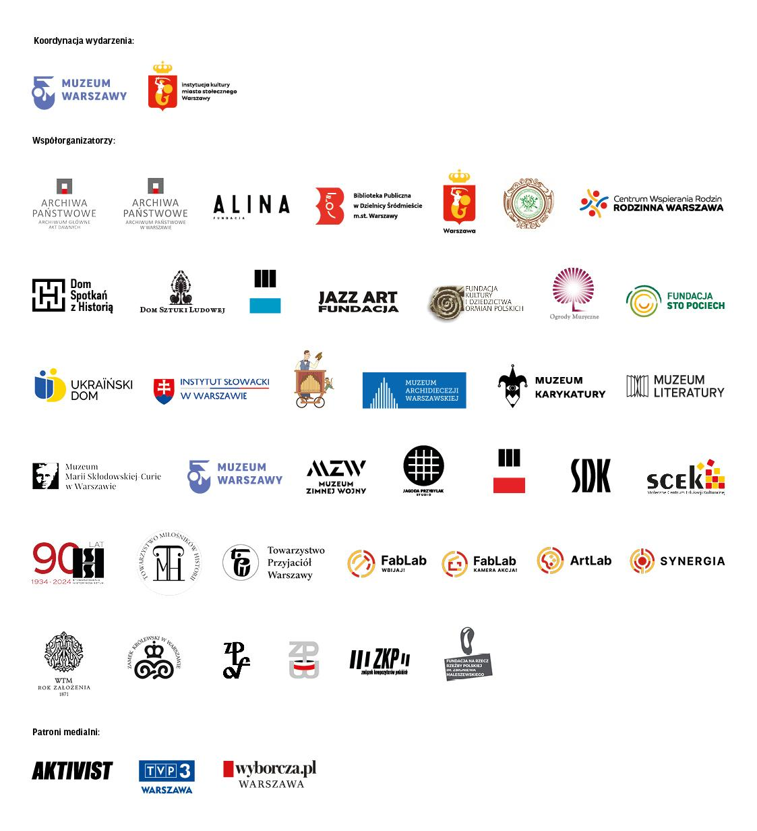

Contact for the media:
Magdalena Gorlas
Museum of Warsaw
magdalena.gorlas@muzeumwarszawy.pl
tel. 22 277 43 94
Information on individual events can be obtained directly from the institutions that organize them.

