Freedom, panache, enthusiasm. EUPHORIA. On Warsaw Club Scene Post-1989 at the Wola Museum of Warsaw

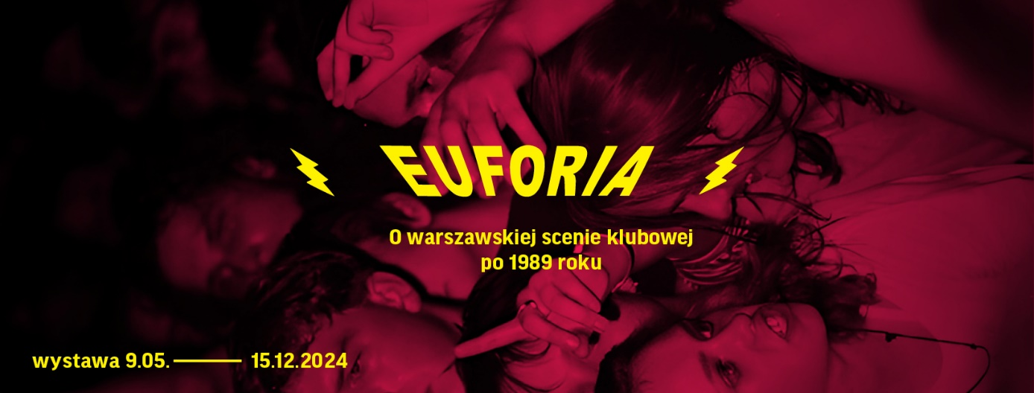
Museum of Warsaw, 9 May – 15 December 2024

The exhibition EUPHORIA. On Warsaw Club Scene Post-1989 recalls important clubs in the Polish capital. Clubs and club-cafés operated at that time within a broader cultural and social context—they were much more than just businesses or venues for concerts and events. It is worth looking at the Polish reality between the fall of communism and accession to the European Union from an unconventional perspective, precisely the way EUPHORIA does.
In a non-obvious way, the Warsaw club scene reflected social, political, and economic changes after the year 1989, i.e. the fall of communism. Fugazi, Filtry, CDQ, and Piekarnia were independent, original initiatives that could only have emerged in the early years of transformation. Seemingly very different from each other, they were connected by pioneering energy, an omnipresent sense of euphoria and community. In the 21st century, club-cafés also appeared on the map of Warsaw—Le Madame and Chłodna 25 were more than just places for concerts and events. Non-governmental organizations were established there, and social movements were formed. These places influenced the development of clubbing and its associated music scene, but they were also strongholds of independent culture—encompassing theatre, visual arts, literature, and being highly inclusive and non-normative spaces.
“EUPHORIA. On Warsaw Club Scene Post-1989 exhibition presents a subjective selection of club venues in the Polish capital that sprang up in the urban fabric after the 1989 transformation and for many years defined the character of the local club scene,” says Konrad Schiller, the exhibition curator. “At the same time, it is a story about the transient characteristic of that era—some venues disappeared from the map of Warsaw as quickly as they had suddenly appeared.”
Not only is this exhibition an insight into Warsaw’s club scene during the period of transformation—it is also an attempt to view an aspect of Warsaw’s cultural heritage which until now has existed mainly in people’s memories. It thus may serve as an inspiration to writing the city’s history from a perspective of its club scene.
“We show both photographs from private collections, video materials and, above all, numerous ephemeral prints: posters, tickets, zines. Many of these have never been presented to the public before,” adds Konrad Schiller.

The moment of glory: Fugazi and Filtry
Anything was possible in post-1989 Warsaw. Private businesses sprang up on every possible scale, and previously state-owned spaces suddenly became available for rent. Through collective effort, they were transformed into unique places that vividly reflected the atmosphere of transformational fever.
Fugazi club operated for mere eleven months, from 10 January to 2 December 1992. Its history began with a 21-day marathon of concerts, and the following ten months saw 150 events and 350 bands, two stages, and doors open almost around the clock. Established stars of independent music, such as Kult, which gave a four-hour concert, performed at the club. Bands like Wilki made their debut there, and performing at Fugazi marked the beginning of Maanam’s great 1990s comeback.
Advertising was non-essential—people just flocked in to the former W-Z cinema. The energy of a never-ending rock party is captured in unique photos of the audience and legends of the independent scene, as well as posters, club cards, and concert programs in the form of a distinctive triangular zine—everything was created by hand, in a punk DIY aesthetic. Colourful, psychedelic murals and paintings adorning the simple, modernist interior were created by Robert Brylewski and Krzysztof "Kain" May. Jurek Owsiak was actively involved in Fugazi, organizing the 50 Rock'n'Rolls for the 1st of May event. During the concert of fifteen bands, funds were raised for organizations such as Monar (Polish non-governmental organization focused on helping drug addicts, the homeless, those who are HIV positive or those who have AIDS). This event is regarded as a harbinger of Owsiak’s Great Orchestra of Christmas Charity.
Filtry club introduced electronic music to the Polish capital from 1992 to 1994. In the basement and boiler room of the Institute of Mathematical Machines—hence the pipes, boilers, and valves—the first techno parties and club raves were held, along with concerts and happenings. Filtry also featured a pioneering resident DJ institution. The raw industrial look was complemented by fluorescent tribal paintings on the walls, ceiling, and floor, glowing under ultraviolet light and strobe lights. The Drastic Dracula Movement group (Xawery Żuławski, Michał Englert, Michał Szałajski, Mateusz Szlachtycz, and Michał Rogalski) was active at the intersection of music and performance.
The sense of vast possibilities and freedom in creating spaces for oneself and one’s community clashed with the darker side of the transformational reality—underworld interests and the ruthless hand of the free market. Although Fugazi and Filtry quickly disappeared from the club map of Warsaw, they turned into legends and served as a starting point for many subsequent initiatives.

Leaving the housing estate: Paragraf 51 and Alfa
Polish rap and hip-hop developed at an incredible pace in the 1990s. With an increasing number of crews and, above all, listeners, the hip-hop culture began to create official venues. Two key clubs for this scene were Alfa and Paragraf 51 (later known as Fresh) where, in addition to concerts and DJ sets, regular breakdance performances and MC battles took place. It was in these venues that Warsaw’s skate-hip-hop community was formed. The explosion of interest in hip-hop and the 1990s Warsaw is well captured in the film titled Skandal. Ewenement Molesty [Scandal. The Molesta Ewenement Group] which, alongside archival photos from the clubs and fragments of TV reports, depicts the beginnings of today’s large, diverse, and largely commercialized music scene.

Clubbing in the mainstream: Piekarnia and CDQ
The late 1990s marked the beginning of venues that would stay on Warsaw’s clubbing map for a long time. For over a decade, Piekarnia drew crowds with its thoughtful line-ups and regular events that quickly gained cult status. Musically, Piekarnia offered house, breakbeat, and acid jazz. Bartek Winczewski and DJ Glasse initiated the "Import" series of events – from that moment, the club regularly hosted international stars. Equally popular were subsequent events: "Back to Groove", "Acieed", and the legendary "Love Bomb!"
CDQ [Centralny Dom Qultury—Central Community Centre] became famous for its excellent and diverse line-up of concerts and DJ sets, regularly hosting artists from abroad. The club was closely associated with libertarian and artistic communities. Drum'n'bass, jungle, and dancehall were played there, and events were held for causes such as Free Tibet, independence for Ukraine, and the Mia100 Women festival. CDQ hosted performances by artists such as: DJ Vadim, Gogol Bordello, Jimi Tenor, Lee "Scratch" Perry, Mad Professor, múm, Peaches, Skatalites, Stereolab, Stereo MC's, The Ukrainians, Zion Train, and Mr. Symarip.

New media: Brum, Plastik, Ślizg, Machina, Radiostacja
In the 1990s, the mainstream media surprisingly devoted a lot of space to alternative culture, which at that time was not strongly separated from mass culture. Announcements and reports on events at Filtry, Piekarnia, or CDQ in Warsaw newspapers surprised no one, just like broadcasts from Radiostacja aired straight from the dance floor. Besides the option of starting a club, it was also relatively easy to start your own magazine. The exhibition features archival issues of Brum, Plastik, Ślizg, or Machina and broadcasts from Radiostacja, the legendary independent station that aired a whole spectrum of sounds: from ethno music, through electronica and hip-hop, to metal and hard-core punk.
In the reality of economic and socio-cultural changes, the club scene influenced the development of media before the emergence of the internet. Both print magazines (such as Brum, Plastik or Machina) and radio stations (Radiostacja) as well as public television treated the dynamics of the club scene as an important aspect of contemporary urban culture.

Communities: Le Madame, Chłodna 25
The beginning of the twenty-first century marked the emergence of a new type of venue – the club-café. These places hosted parties and concerts in the evenings, but they also thrived during the day as open social spaces.
Le Madame was a café, dance floor, theatre stage, art gallery, but also a venue for public discussions and political activity. This club-café was characterized by radical openness and inclusivity towards groups marginalized due to identity, sexuality, or disability. Le Madame was an open space for the LGBTQ+ community and hosted various organizations including Zieloni 2004, the Women's 8 March Agreement, Kino Polska, Andrzej Wajda Master School of Film Directing, the Institute of Applied Social Sciences at the University of Warsaw, Pro Varsovia, the Drama Association, and the Polish Association of Rationalists.
The sense of community at this venue was poignantly expressed during a sad event—the protest against the club’s eviction. The several-day occupation of the venue was captured on film by Joanna Rajkowska in Le Ma! It is easy to see in the film that it was a haven for the truly colourful people and an extremely important place on the map of Warsaw.
Since its opening in 2004, Chłodna 25 operated as a venue open to all initiatives, responding to the needs of its guests. It served coffee, had regular Sunday breakfasts, and hosted evening concerts and parties, however debates, workshops, film screenings, art exhibitions, and neighbourhood community meetings were equally important. This new format of activity led to the formation of artistic and social initiatives at Chłodna 25, many of which today shape Polish politics and culture.
Regular activities at Chłodna 25 included: “Ę” Society for Creative Initiatives, the Anthropological Passage Association, Dwutygodnik online magazine, the Klancyk Improvisation Theatre, the Montownia Theater Foundation, and "Stocznia" Workshop for Social Innovation and Research.

DJ sets, guided tours, meetings and debates
As part of the accompanying program from mid-May until the end of September, DJ sets will take place in front of the Wola Museum on the first and last Saturday of the month, weather permitting. The first set is scheduled for 25 May and will be inspired by the activities of the Fugazi and Filtry clubs.
In May, we invite our audience to three curator-guided tours: on 11, 16, and 30 May.
On the Night of Museums – 18 May – our guests will have an opportunity to watch films and participate in a special guided tour.
Additionally, there will be meetings and debates with club founders and DJs, complemented by displays of archives related to other Warsaw clubs not featured in the exhibition.

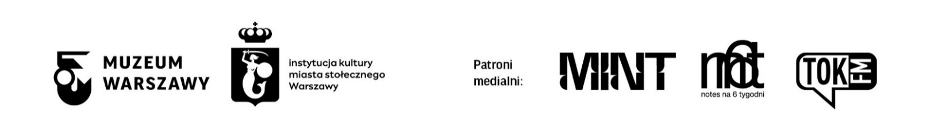
EUPHORIA. On Warsaw Club Scene Post-1989 exhibition is open for viewing from 9 May until 15 December 2024 at the Wola Museum of Warsaw at 12 Srebrna Street. The Museum is open on Tuesdays, Wednesdays and Fridays from 9AM to 6PM, on Thursdays from 11AM to 8PM, on Saturdays and Sundays from 11AM to 7PM. Tickets: 15PLN/10PLN, on Thursdays admission is free.

Contact for the media:
Aleksandra Migacz
Museum of Warsaw
22 277 43 45, 723 249 094
aleksandra.migacz@muzeumwarszawy.pl

Materials for the media:
www.muzeumwarszawy.pl/dla-mediow

COLOPHONE
curator Konrad Schiller
exhibition design Anna Sarnowska
production Michał Tański
graphic design Monika Nawrocka
poster design Joanna Bębenek
translation Skrivanek
editing and proofreading Urszula Drabińska
implementation Ksenia Góreczna, Katarzyna Radecka, Leszek Sokołowski, Piotr Lipiński, Paweł Grochowalski, Tomasz Raubo, Artur Miniewicz, Michał Bogumił, Krzysztof Hernik, Krzysztof Kwiatkowski, Dariusz Sałański
multimedia Filip Wielechowski-Olszak, Tomasz Raubo
external loans Janusz Kurczak
accessibility Karolina Sawicka
accompanying program Konrad Schiller, Magdalena Staroszczyk, Katarzyna Żukowska
multimedia Filip Wielechowski-Olszak, Tomasz Raubo
communications and marketing Joanna Andruszko, Małgorzata Czajkowska, Agata Fijałkowska, Agata Fronczyk, Klaudia Gniady, Dagmara Jędrzejewska, Daniel Karwowski, Anna Ładna, Aleksandra Migacz, Jowita Purzycka, Milena Soporowska
loans from institutions and private collections
The National Library
Joanna Rajkowska
Irena Herka
Katarzyna Szustow
Ninateka
National Digital Archiva
Kręcioła TV Foundation
BestFilm
Raban Foundation
Dawna Stara Radiostacja Group
Waldemar Czapski
Stanisław Trzciński
Mateusz Szlachtycz
Tomasz Wójcik
Michał Narojczyk
Irena Herka
Daniel Dash
Jarosław Guła
Katarzyna Szustow
Grzegorz Lewandowski
Joanna Rajkowska

authors
Waldemar Czapski
Piotr Wolfram
Tomasz Dominik
Piotr Rozbicki
Andrzej Rybczyński
Leszek Gnoiński
Tomasz Wójcik
Mateusz Szlachtycz
Michał Narojczyk
Daniel Dash
Bartosz Paduch

