Gloss, Matt, Colour. Photography and Warsaw in the 1990s – the exhibition of over one thousand photos opens on 20 October at the Museum of Warsaw.

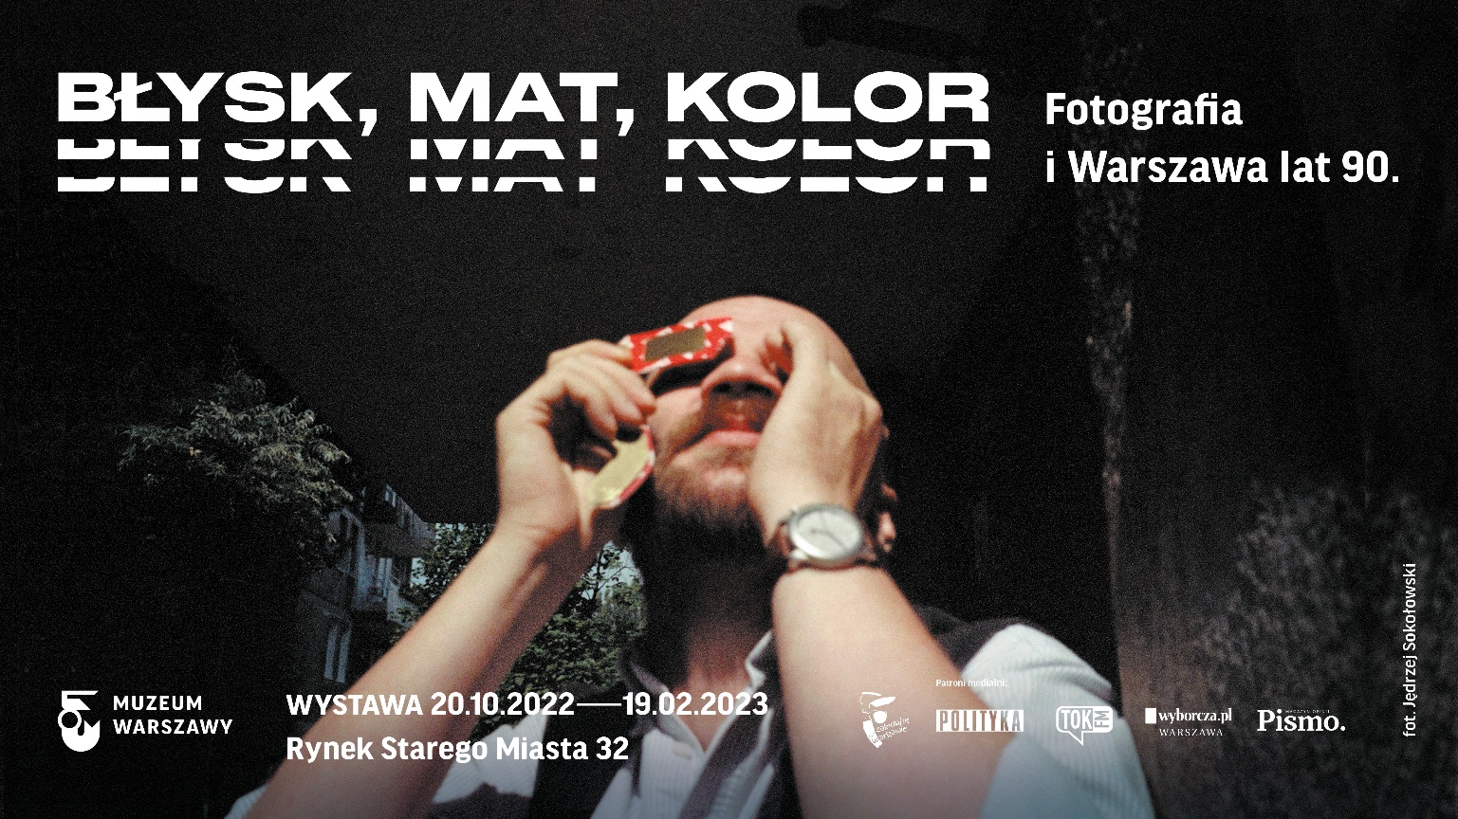
Museum of Warsaw, 20.10.2022–19.02.2023
The 1990s: a decade of contrasts, changes, breakthroughs that were in most part captured by a photo camera. Professional and amateur, reportage and art photography conjures up a captivating portrait of Warsaw of the 1990s. Visitors to the Museum of Warsaw will have an opportunity to view over 1,000 photos and films by almost 100 authors including Hartwig, Niedenthal, Rolke, Miller, Bohdziewicz, Musiałówna, Biała or Łoziński from 20 October 2022 at the Gloss, Matt, Colour. Photography and Warsaw in the 1990s exhibition.
Jarmark Europa market, Cricoland, the first McDonald’s restaurant, posters of the first free elections and ads, trade carried out from camp beds, „jaws” and Yugo-kiosks, Józef Tkaczuk, the first day of spring but also drug related problems, poverty and strikes.
No other media tell the story of the 1990s and Warsaw as well as photography does. Photographs, both amateur and professional, captured the decade of transformation and its impact on the cityscape. Gloss, Matt, Colour exhibition at the Museum of Warsaw reaches into the archives of professional photographers, photojournalists, artists, but also into private family albums. Back then, analogue photography was a common way of recording reality that was changing and surprising. Colourful advertisements took over the urban space, glass high-rises sprang up, free trade took over the streets, protests and strikes followed. How was this time of violent change captured by photography? How was the city perceived back then? To what extent is our memory of the 1990s based on photography?

Over 1,000 photos, films, postcards
Over 1,000 objects—photographs, films and postcards—have been arranged in six rooms. Whenever possible, original materials are presented: characteristic small prints, contact sheets and slide shows. Thus, the material aspect of photography has become one of the exhibition’s themes. Exposition’s sections have been named using words or expressions drawn from a photography-related vocabulary which at the same time relate to the reality of the 1990s—colour, contrast, narrative or typology.

Professional and amateur photographers
Selecting authors and works was by no means an easy process. Next to the distinguished photographers (Edward Hartwig, Tadeusz Rolke, Chris Niedenthal, Anna Beata Bohdziewicz, Anna Musiałówna), we present works by the young generation which was entering the free media market in the 1990s (Maria Zbąska, Piotr Wójcik, Krzysztof Miller), artists (Zofia Kulik, Paweł Althamer, Teresa Gierzyńska), press photographers (Kacper M. Krajewski, Anna Biała, Adam Marzec), feature and documentary filmmakers (Marcel Łoziński, Krzysztof Kieślowski, Barbara Sass). One section of the exposition is dedicated to non-professional photography—amateur, family, commemorative. Thanks to the involvement of more than 40 people who responded to the call for a collection of non-professional photographs depicting Warsaw in the 1990s, photographs from their private collections were included in the story of memory co-created by photography, pointing to the subjects invisible from the perspective of photojournalism or from the field of art.

Gloss, Matt, Colour. Photography and Warsaw in the 1990s publication
The exhibition is complemented by a book edited by Karolina Puchała-Rojek. It features 250 photos by over a dozen authors, many published for the first time. The photos are accompanied by excerpts from interviews conducted by Julia Staniszewska with experts in photography in the 1990s, among others the owner of the famous Relax lab, as well as essays by Karolina Puchała-Rojek, Adam Mazur and Witold Kanicki, and by Błażej Brzostek’s personalised review of events from the 1990s. The stories of Warsaw and photography are intertwined in this volume.

The accompanying program: guided tours, debates, workshops, museum lessons and film screenings at the Syrena Cinema
Every Sunday you will have an opportunity to join a guided tour of the exhibition. In addition to curator- and educator-guided tours, there will be special tours guided by guests including Olga Drenda, Magda Szcześniak, Marcin Wicha, Monika Borys and Jacek Paśnik. On Thursdays, we will hold debates. The program also includes architectural and photographic walks and workshops.
The exhibition will also be accompanied by a film program at the Syrena Cinema. Five film screenings will be followed by meetings with filmmakers chaired by Dorota Chrobak, Kaja Klimek and Olga Drenda. Invited guests are: Maciej Drygas (director of the film titled Usłyszcie mój krzyk), Maria Pakulnis (leading role in Barbara Sass' film titled Pajęczarki), Marcel Łoziński (director of the film titled 89 mm od Europy), Maria Zmarz-Koczanowicz (director of films Nie wierzę politykom and Moja Warszawa).
WFDiF – owner of the 35mm.online streaming platform—is the film program partner.

Photography at the Museum of Warsaw
The photography collection is one of the most extensive at the Museum of Warsaw, comprising approximately 300,000 items: historical and contemporary negatives and photographic prints on various backings, as well as a fine collection of photographic albums. Thanks to numerous donations and purchases, the collection is regularly enriched by new acquisitions. Recent additions include works by contemporary photographers who tell the story of Warsaw: series by Antonina Gugała, Rafał Milach, Jędrzej Sokołowski and Joanna Szpak-Ostachowska.
“Photography Centre in operation at the Museum in Warsaw is currently undergoing intensive development,” says the Centre's coordinator and exhibition curator Karolina Puchała-Rojek. “We're working on a program that will meet the needs of our audience: we're preparing another exhibition and a program for young people, we're organising events engaging contemporary artists. Above all, we are gradually making the collections available for viewing on the Warsaw Museum Collections portal," adds Puchała-Rojek.
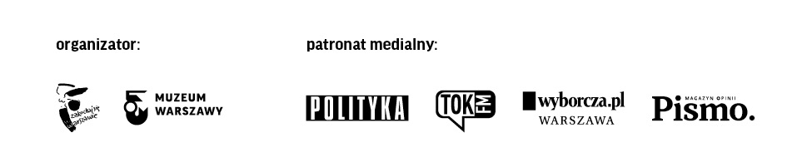
Gloss, Matt, Colour. Photography and Warsaw in the 1990s exhibition will be open from 20 October 2022 until 19 February 2023 at the Museum of Warsaw at 32 Old Town Market Square. The Museum is open on Tuesdays, Wednesdays and Fridays between 9AM and 7PM, on Saturdays between 11AM and 7PM and on Sundays between 11AM and 5PM. Ticket price: 12PLN / 7PLN; on Thursdays admission is free.

KOLOFON

Curator Karolina Puchała-Rojek
Curatorial cooperation Julia Staniszewska
Production Zofia Zajkowska
Exhibit design Aneta Faner Studio
Text editing Ewa Kiedio
Translation Zofia Sochańska
Realisation Ksenia Góreczna, Katarzyna Radecka, Ewa Lenczewska, Krzysztof Hernik, Krzysztof Świerczewski, Paweł Grochowalski and Administration and Technical Department team
ConservationIgor Nowak, Paulina Miąsik, Robert Kołodziejski, Piotr Popławski
Digitisation Mikołaj Kalina (coordination), Adrian Czechowski, Michał Matyjaszewski, Anna Sulej
Post-production Anna Sulej
Pre-press Karol Bagiński (FOTO-GRAFIKA)
External loans Janusz Kurczak, Piotr Niwiński, Marta Szotkowska
In-house loans Dorota Parszewska
Legal assistance Monika Góra
Accessibility Katarzyna Szafrańska
Graphic design of promotional materials Joanna Bębenek
Accompanying program Nicola Cholewa, Wanda Kaczor, Alicja Małecka, Dorota Migas-Mazur, Anna Zdanowska, Marcin Matuszewski, Karolina Iwańczyk
Exhibition custodians Agnieszka Dzieniszewska, Joanna Grabowska, Tomasz Jakubik, Emilia Kulczycka, Bogusław Kurek, Mateusz Korol, Patrycja Korol, Adam Kurkowski, Zofia Kurkowska, Roman Raba, Elżbieta Tańska, Franciszek Wicherkiewicz
Communications and marketing Joanna Andruszko, Olga Baron, Melissa Czaplicka, Matylda Dobrowolska, Daniel Karwowski, Aleksandra Koszalska, Anna Ładna, Aleksandra Migacz, Jowita Purzycka, Filip Wielechowski-Olszak
Objects exhibited courtesy of Agencja East News, Agencja Wyborcza.pl, Biblioteka Uniwersytetu Warszawskiego, Anna Beata Bohdziewicz, Błażej Brzostek, Katarzyna Bułtowicz, Centrum Sztuki Współczesnej, Tomasz Chmal, Filmoteka Narodowa, Fundacja Archeologia Fotografii, Fundacja Galerii Foksal, Fundacja Kulik-Kwiekulik, Fundacja Ośrodka Karta, Galeria Gunia Nowik, Galeria Le Guern, Łukasz Gorczyca, Iwona Grodzka, Jerzy Gumowski, Janusz Kobyliński, Kacper M. Krajewski, Marcel Łoziński, Anna Musiałówna, Muzeum Historii Fotografii im. Walerego Rzewuskiego w Krakowie, Chris Niedenthal, Persons Projects, Kacper Pempel, Marcin Poletyło, Tomek Sikora, Basia Sokołowska, Jędrzej Sokołowski, Juliusz Sokołowski, Tomasz Waciak-Wójcik, Przemysław Wierzchowski, Maria Zbąska and all the participants of the “Create a 1990s’ photo collection with us” action
We extend our thanks to all those who have contributed to the exhibition Aleksandra Grabeus-Szmelig, Beata Grochowicz, Olga Guzik-Podlewska, Patrycja Jastrzębska, Joanna Krupa, Mikołaj Łoziński, Beata Łyżwa-Sokół, Tadeusz Matan, Magdalena Nowak-Gniadek, Gunia Nowik, Ewa M. Porębska, Marta Przybyło, Małgorzata Sydorczyk, Wiktoria Szczupacka, Aleksandra Ściegienna, Nina Wojciechowska, Piotr Wójcik, Grażyna Zdebiak, Asia Zak-Persons
Special thanks Wyborcza.pl Agency, ”Masław” Mazovian Region Lovers Association—”Tu było, tu stało” project, Documentary and Feature Film Studios [WFDiF], Jewish Historical Institute

Materials for the media: www.muzeumwarszawy.pl/dla-mediow

Contact:
Aleksandra Migacz
Muzeum Warszawy
22 277 43 45, 723 249 094
aleksandra.migacz@muzeumwarszawy.pl

