An Icon of Polish Design. Exhibition of Julia Keilowa’s Artwork at the Museum of Warsaw
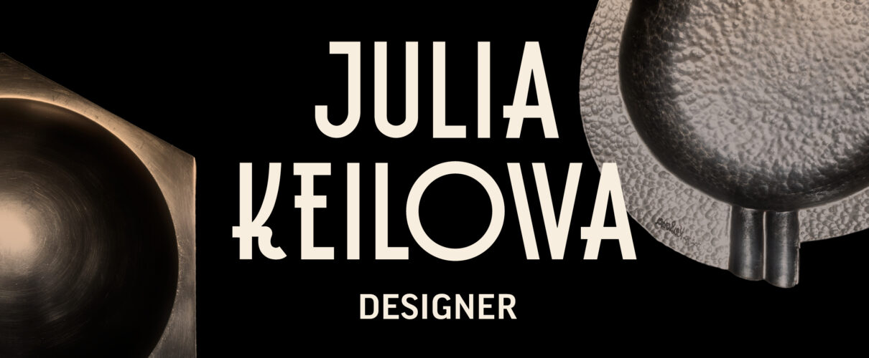
Museum of Warsaw, 21 March – 1 September 2024

The exhibition Julia Keilowa. Designer is the first comprehensive presentation of the oeuvre of an outstanding Warsaw-based metal artist, one of the leading figures in the history of Polish design. Keilowa’s career lasted less than a decade, brutally interrupted by the Second World War, and yet she managed to gain fame and recognition in the then male-dominated field. Thus, the exhibition also presents a broader phenomenon of female designers’ emancipation and of the elevation of design to the rank of art—a process which took place in the first decades of the 20th century. Unique objects designed by Sonia Delaunay, Jutta Sika and Christa Ehrlich lend an international context to Julia Keilowa’s works.

Julia Keilowa designed everyday objects in the Art Déco style. Her artistic education and sculptural experience allowed her to develop her own distinctive style. Thanks to the popularity of plating, a technique of covering non-precious metal products with a thin layer of silver or gold, her designs entered the salons of the Second Republic of Poland, earning Keilowa fame and recognition. Attempts to imitate her style were made as early as the 1930s, there were even forgeries of her products, which testifies to the significance of Keilowa’s design and to her status. Today, Keilowa’s metalwork belongs to the canon of masterpieces of Polish design, and her works are sought after in the collectors’ market as coveted additions to both public and private art collections.
The exhibition is not only the largest presentation of Julia Keilowa's works to date but also an opportunity to get acquainted with the oeuvre of female pioneers of design in the Art Déco style: Sonia Delaunay and Jutta Sika from the Vienna Workshops. Works by women designers contemporary to Keilowa, active in the Netherlands and Sweden, are also unfamiliar to the Polish audience. Like Keilowa, Christa Ehrlich and Sylvia Stave designed modern, functional metal objects for the industry.
“The idea for the exhibition stemmed from our admiration for the beauty of the objects designed by Julia Keilowa. These metal trays, ashtrays and vases fit perfectly into the aesthetics of the 1930s. At that time, they were perceived as modern, elegant and indicative of the refined taste of their buyers. After World War II, they fell into oblivion, only to make a grand comeback in the 1990s,” explain the exhibition curators Agnieszka Dąbrowska and Monika Siwińska. “Today, we also appreciate their functionality, the artist’s awareness of the material’s quality as well as the originality of design solutions which result, among others, from her education in sculpture and her sense of humour. Julia Keilowa’s ideas turned out to be timeless,” add the curators.

Julia Keilowa, née Ringel (1902–1943)
Julia Ringel was born in 1902 in the town of Stryj, today in Ukraine, into a Jewish family. She attended high school in Lvov and Vienna. In 1922, she married Ignacy Keil and moved to Warsaw with him. Three years later she began her studies at the State School of Fine Arts in the sculpture department. In 1932, she started collaborating with the Warsaw-based Fraget metalwork company, and later with Norblin and Henneberg Brothers factories. Her Art Déco-style projects quickly gained recognition from critics and customers alike. In 1933, Julia set up her own metalwork studio. From 1932 to 1939 she took an active part in the artistic life of the capital, systematically presenting sculptures and utility items at group exhibitions, also abroad, and winning prizes. In 1938, she had an individual exhibition of silver-plated objects. Keilowa was known among friends and fellow artists for her energy and vigour, as well as for her initiative and ideas. Following the outbreak of the Second World War, she fled to Lvov where she ran a ceramics studio. After two years, she returned to Warsaw and hid on the ‘Aryan’ side. She was murdered by the Gestapo in 1942.

An outstanding designer of the Second Polish Republic
Phenomena characteristic of the first decades of the 20th century, and especially the 1930s in Warsaw, manifest themselves in the course of Keilowa’s short life and in less than a decade of her intensive career. The division between fine and applied arts blurs, art schools begin to train designers, and women designers gain recognition and build their careers on par with family life. Industry employs more and more designers and builds its brand through their work. Elegant Art Déco silver-plated items compete with more expensive silver ones. In Poland, reborn in 1918 after over a century under Partitions, modern design was aimed to support the modernization of the young state. Keilowa’s metalwork often served as a symbol of the Second Republic’s art.
Without a doubt, Julia Keilowa took advantage of the opportunities she had but, to be sure, her talent, creativity, perseverance, diligence, and consistency in creating a distinctive style were essential. Today, one could safely state that the designer consciously—and at an extraordinary pace—built a personal brand. Her name stood for beautiful, utilitarian objects, manufactured on a large scale yet still considered works of art.

Female pioneers of modern design and Art Déco style
The life stories of Keilowa’s contemporary and older female designers in Europe—Sonia Delaunay, Jutta Sika, Christa Ehrlich, and Sylvia Stave—are similar, though not identical. Their work, on display in this exhibition, expands the tale of design as an equal domain of art and of female designers who were true artists. Among others, the exhibition will feature gouaches and fabrics designed by Delaunay from the collections of the Musée des Artes Décoratifs in Paris, porcelain and glass by Jutta Sika from the collection of the Museum of Applied Arts in Vienna, metalware objects by Christa Ehrlich from the Dutch Silver Museum in Schoonhoven, and by Sylvia Stave from a private collection. An overview of the best Art Déco design is complemented by a selection of objects from Poland and abroad, coming from private collections, museums, and the Museum of Warsaw collection.
Sonia Delaunay (1885–1979) was a French painter of Ukrainian-Jewish origin, a designer of fabrics and clothing. At the beginning of the 20th century, together with her husband Robert, she co-created the Parisian bohemia. Their avant-garde painting, born from a fascination with colour and abstraction, was dubbed Orphism or Simultanism. In 1911, Delaunay sewed a quilt for her son with a colourful composition in the spirit of Orphism, and in the following decades, she created several hundred designs for fabrics, clothing, and everyday objects. She designed costumes for Sergei Diaghilev’s Russian Ballets and patterns for silk fabric from Lyon factories. She created a trademark, had her own boutique at the World’s Fair in Paris in 1925, and the clothes she designed were worn by Hollywood stars.
Jutta Sika (1877–1964) was an Austrian applied arts designer, graphic artist and educator. In 1901, she was one of the co-founders of the Wiener Kunst im Hause group, which in 1903 transformed into the Wiener Werkstätte (Vienna Workshops). The mission of this artistic cooperative was to make the roles of the designer and the craftsman equal by collaboratively creating everyday objects accessible to a wide audience. Artists associated with the Wiener Werkstätte valued simple forms and meticulous craftsmanship. Adhering to these ideas, Jutta Sika successfully designed ceramics and glass, and collaborated with well-known Austrian factories. She also prepared designs for clothing, Christmas decorations, postcards, and packaging.
Christa Ehrlich (1903–1995) was an Austrian designer who graduated from the Kunstgewerbeschule and was active within the Vienna Workshops circle. She was an employee at Josef Hoffmann’s architectural office. In 1927, she began working as a designer for De Zilverfabriek Voorschoten, a large Dutch silversmith company. With no previous experience in working with metal, Ehrlich quickly grew to enjoy her new role. She designed utensils in the Art Déco style, which soon gained renown among the Voorschoten customers. Ehrlich remained associated with the Dutch firm for the rest of her professional life. She also designed ceramics for the Regout porcelain factory in Maastricht as well as catalogues and advertising materials for the Voorschoten factory.
Sylvia Stave (1908–1994) was a Swedish designer. She studied at the Tekniska Skolan in Stockholm, a higher education institution focused on art, design, and crafts. In her youth, she was an athlete and represented Sweden in international athletics competitions. In 1929, she joined the prestigious C.G. Hallbergs Guldsmedsaktiebolag silversmith company in Stockholm. At the age of 25, she was appointed its artistic director. Stave designed applied art objects in the Art Déco style. In 1940, she got married, moved to France, and abandoned her job as well as her burgeoning career.

The most comprehensive presentation of Keilowa’s oeuvre
However, the core of the exhibition are nearly 80 objects designed and created by Keilowa. This is the most extensive presentation of her work to date, encompassing handcrafted unique items and sculptural works. Keilowa’s legacy was dispersed during World War II. In the decades following the end of the War, the designer fell into oblivion, also due to the change in political system. The socialist Polish state deliberately obliterated the memory of the Polish Second Republic’s achievements, nationalized the silver plating factories and ignored the copyright issues. At the same time, aesthetic preferences changed, and the style of the 1930s seemed outdated. The last few decades have seen a revival of Art Déco and a rediscovery of Keilowa’s artistic output.

“The exhibition at the Museum of Warsaw is the first such comprehensive presentation of Julia Keilowa’s oeuvre. It presents dozens of her works, normally scattered in both public and private collections. We are also making an attempt at organizing the attributions, namely indications as to when Keilowa’s authorship is certain or supported by source materials, and when it is only attributed,” say the exhibition curators, Agnieszka Dąbrowska and Monika Siwińska. “This challenge is akin to putting together an incomplete puzzle, and yet we do hope that the exhibition and the publication that accompanies it will serve as a solid foundation for future researchers of Keilowa’s work. The exhibition also features a number of personal memorabilia of the designer. These are unique items that shed light on her vibrant personality,” the curators add.

Sphere sugar bowl, Three triangles decorative plate, a three-sided plater
Objects designed by Julia Keilowa stand out with their distinctive style, balanced composition based on mathematical proportions, pursuit of harmony, rhythm and elegance. The artist was keen on juxtaposing basic geometric volumes—cones, cylinders, spheres, prisms. Their arrangement is clear and precisely matched, balanced. However, the volumes are neither heavy nor angular. Sharp forms are softened by curves, arcs, and crescent bends. Keilowa had favourite shapes and she skilfully applied them in her various projects. Her designs are marked by a profound awareness of form and space. Despite their small scale, a sculptural approach to the shapes of objects is evident. The artist also used light skilfully. Gloss, reflections and the shadows contrasting with them are distinctive features of silvery metal. It is not the richness of ornamentation and decorations, but rather the original combination of simple forms, soft edges and rhythmic steps that construct the extraordinary decorativeness of the objects designed by Keilowa.
Benedykt Jerzy Dorys repeatedly photographed sugar bowls, platters, ashtrays, bowls, and candlesticks designed by Keilowa. His excellent black-and-white photos reveal the distinctive style and beauty of these objects. Light reflections, shine and the contrast of forms play a major role also today in a photographic session realised specially for the Museum of Warsaw by Filip Preis. The young artist has produced unique photos characterised by a dreamlike ambience.

Julia Keilowa today
In the final section of the exhibition, visitors will have an opportunity to explore a contemporary perspective on the figure of Julia Keilowa and her oeuvre. Students from the Warsaw Academy of Fine Arts and the School of Form will present over thirty modern design solutions inspired by her work.
Visitors to the exhibition will also have a chance to try their hand at designing. Materials for paper crafting will be provided on a workshop table. When in the 1920s and 1930s students at the Academy of Fine Arts in Warsaw developed their design skills in classes dedicated to the composition of volumes and planes, one of the exercises was precisely to create spatial forms from paper. The intricately folded and bent pieces of cardboard testified to their formal discipline, sense of space, great imagination, and sense of humour.

First catalogue of Keilowa’s design
The exhibition is accompanied by a bilingual (PL-EN) publication titled Julia Keilowa. An Art Déco Designer, edited by the exhibition’s curators, Agnieszka Dąbrowska and Monika Siwińska. The book will provide an insight into the designer’s life story, her artistic workshop, career path and methods of building her own brand. The book also includes the first catalogue of Keilowa’s metalwork objects, covering the documented designs attributed to her and demonstrating the quality of her incredibly rich oeuvre, produced over such a short period of time.

Julia Keilowa. Designer exhibition will be open for viewing from 21 March until 1 September 2024 at the Museum of Warsaw at 32 Old Town Market Square. The Museum is open on Tuesdays, Wednesdays, Fridays and Saturdays from 11AM till 7PM, on Thursdays from 11AM till 8PM, and on Sundays from 11AM until 6PM. Tickets: 20PLN / 15PLN. On Thursdays, the admission is free.

The exhibition is accompanied by a book titled Julia Keilowa: An Art Déco Designer edited by Agnieszka Dąbrowska and Monika Siwińska.

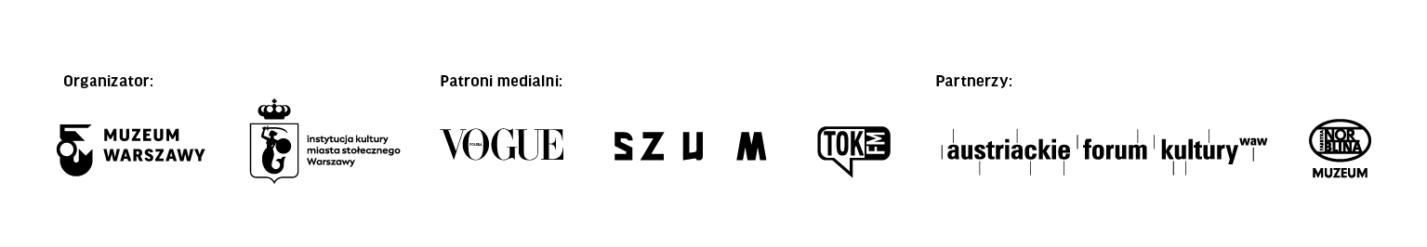
More information about the exhibition and the accompanying program is available here: www.muzeumwarszawy.pl/en/wystawa/julia-keilowa-designer/

Contact for the media:
Aleksandra Migacz
Museum of Warsaw
22 277 43 45, 723 249 094
aleksandra.migacz@muzeumwarszawy.pl

Materials for the media:
www.muzeumwarszawy.pl/dla-mediow

