### ***Sylwester “Kris” Braun. A Photographer of the Uprising* – a unique exhibition and a book to commemorate the 80th anniversary of the Warsaw Uprising**

### Museum of Warsaw, 30 July 2024, 6PM

### 

### **Photographs taken by Sylwester “Kris” Braun are amongst the most important documents from the Warsaw Uprising. In the exhibition Sylwester “Kris” Braun. A Photographer of the Uprising to open soon at the Museum of Warsaw, we present original prints developed by Braun himself. The exposition poses a question: when and how a biographical account turns into a historical narrative? It also introduces to the public Berta Weissberger, Braun’s assistant. On 30 July, we invite you to a book launch of an album under the same title, in which over 200 photos are accompanied by texts penned by Piotr Głogowski, Iwona Kurz, Tomasz Stempowski and Tomasz Szerszeń. The authors reveal fragments of Braun’s biography thus far unknown to the public and analyze his photographic techniques, the routes he followed as a photographer, as well as the iconography of the photos from the Uprising. The exhibition and the album are part of the commemorative program on the 80th anniversary of the Warsaw Uprising organized by the Museum of Warsaw.**

**Sylwester Braun aka ‘Kris’** is one of the most important photographers of the Warsaw Uprising. Many of his photos taken in 1944 are now regarded as iconic. They are widely recognised and often referred to as the images of the Uprising, even if not identified by captions. Braun’s original prints are the most precious objects related to the Warsaw Uprising in the Museum of Warsaw’s photographic collection. Presenting them in the form of an exhibition and an album is our way to commemorate the 80th anniversary of the Uprising.

**On 30 July at 6PM** there will be a book launch of the album and opening of the exhibition, both titled **Sylwester “Kris” Braun. A Photographer of the Uprising**. During the meeting at the Museum of Warsaw’s Lapidarium at the Old Town Market Square, authors of the book will talk about the photographs and about the man who took them. The meeting will be chaired by Karolina Puchała-Rojek from the Museum of Warsaw’s Center of Photography. After the meeting, we will open the exhibition. It will be available for viewing as part of the Museum’s Core Exhibition until 29 December 2024.

“The story of photos taken by Braun is not limited to the moment of film exposure,” says Piotr Głogowski, exhibition curator. “Their turbulent history involves them being hidden and then recovered, their long journey across the globe with a large amount of them getting lost and, finally, their inclusion in the Museum’s collection. Identifying and establishing contact with Berta Weissberger—Braun’s assistant and author of some of the photographs, who emigrated to the United States and adopted the name Betty Lauer after getting married—sheds new light on these works.”

The exhibition ***Sylwester “Kris” Braun. A Photographer of the Uprising*** offers a unique opportunity to see original prints made by Braun, to follow in the footsteps of the couple of photographers who traversed the city in the midst of the combat, and to check how a documentary record of events became a widely known narrative on the Warsaw Uprising.

The exhibition reflects the photojournalistic nature of Braun's photographs, which is largely due to the fact that they form closed, well-studied series. The shots capture the daily life of the fighting city on a micro scale, showing its heroic moments—sometimes joyful, more often poignant and tragic. A checkpoint at a barricade, a piano concert, and well drilling are seemingly trivial themes that gain a profound significance when juxtaposed with other simultaneous events, such as the funeral of victims, a ride in a captured transporter, and the escorting of a column of prisoners.

Braun’s biography and, above all, the re-establishment of Berta Weissberger as an important protagonist in the story, demonstrates how many factors affect the creation and reception of historical narratives. During the Uprising, Braun had a pass that allowed him to move freely around the liberated areas of the capital city. He personally chose the subjects and scenes to photograph, and the prints he selected were distributed by the Home Army’s Bureau of Information and Propaganda. After the war, he made attempts to popularize his photographs, and when the political situation in the 1980s and 1990s allowed for the return of the Uprising iconography and for Braun’s own return to Poland, he actively participated in organizing exhibitions and book publications.

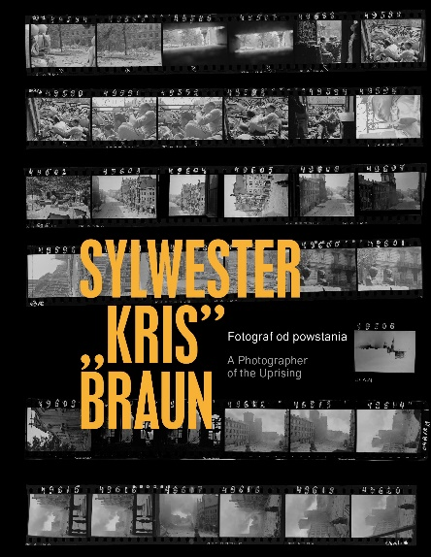Thanks to many years of research carried out by the exhibition curator Piotr Głogowski, the locations captured in the photographs, the exact dates, and even the times of day when they had been taken have been identified, making it possible to reconstruct the routes Braun had followed and to reassemble the strips of negatives he had cut back into their original rolls.

The themes explored in the exhibition are further developed in the album under the title ***Sylwester “Kris” Braun. A Photographer of the Uprising***. The fascinating life story and the rich body of work of one of the most important photographers of the 1944 Warsaw Uprising are described in the texts written by Piotr Głogowski, Iwona Kurz, Tomasz Stempowski and Tomasz Szerszeń. The publication follows in Braun’s footsteps through wartime Warsaw, analyzes his photographic techniques, and places his work in the context of other photographers of August and September 1944. Equally important is the legend Braun created about himself and the role his photographs play in the current narrative on the Warsaw Uprising. The album contains over two hundred of Braun’s photographs, primarily from 1944, as well as a selection of newspaper clippings and excerpts from correspondence. The book is published in a bilingual Polish-English edition.

**The exhibition and the album are part of the commemorative program on the 80th anniversary of the Warsaw Uprising organized by the Museum of Warsaw. The program includes meetings, concerts, walks, debates, film screenings and presentations of keepsakes from the time of the Uprising.**

**For more details, please go to:** [**www.muzeumwarszawy.pl/obchody-80-rocznicy-powstania-warszawskiego/**](http://www.muzeumwarszawy.pl/obchody-80-rocznicy-powstania-warszawskiego/)**.**

**Sylwester “Kris” Braun** (1909–1996) was active in the resistance as a member of the Union of Armed Struggle and later the Home Army. During the Warsaw Uprising, dressed in civilian clothes and equipped with a small Leica Standard camera tucked in his jacket pocket, he roamed the streets of Śródmieście, central Wola, and Powiśle quarters. He paid close attention to the composition of his shots, often taking various perspectives by climbing onto roofs or standing right behind the defenders of barricades. He frequently repeated shots, making slight adjustments. Braun captured the ruins and ongoing combat as well as moments of respite, such as a piano concert at the ‘U Aktorek’ café.

Although most of the photos and negatives were destroyed in a fire in the photographer’s apartment in Powiśle, some of the films were hidden in jars in the basement of a building on Marszałkowska Street and recovered after the war ended. With time, the photos from the Uprising became increasingly recognizable but their author, who had been living abroad for many years, remained largely unknown. It was not until 1979, thanks to an initiative by Kurier Polski, that Sylwester Braun’s life and work were popularized. In 1981, the photographer donated a collection of over 1,500 surviving negatives to the Museum of Warsaw.

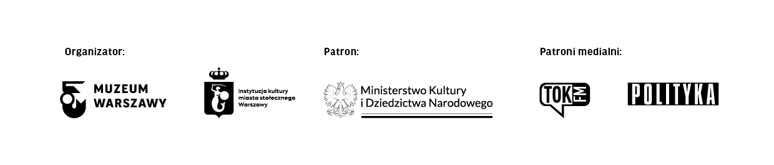***Sylwester “Kris” Braun. A Photographer of the Uprising* exhibition will open on 30 July 2024 at 6PM in the Museum of Warsaw at 42 Old Town Market Square. The exposition will be available for viewing as part of the Core Exhibition at level 1. Opening hours: Tuesday, Wednesday, Friday and Sunday 10AM-6PM, Thursday 10AM-8PM and Saturday 11AM-7PM. Tickets: 25PLN/18PLN; on Thursdays admission is free. For more information on the exhibition and the accompanying program, please go to:** [**www.muzeumwarszawy.pl**](http://www.muzeumwarszawy.pl)**.**

Subsidized by the Ministry of Culture and National Heritage from the Culture Promotion Fund—a state earmarked fund and the Ministry of Culture and National Heritage.

**COLOPHONE**

**curator** Piotr Głogowski

**cooperation** Karolina Puchała-Rojek

**exhibition design** Studio ŚŃŃ Maciej Chodziński, Katarzyna Łygońska, Tomasz Świetlik

**production** Katarzyna Jolanta Górska

**graphic design of the poster and promotional materials** Anna Światłowska

**editor** Urszula Drabińska

**translator** Aleksandra Szymczyk

**technical setup and implementation** Ksenia Góreczna, Paweł Grochowalski, Krzysztof Hernik, Piotr Lipiński, Artur Miniewicz, Katarzyna Radecka, Tomasz Raubo, Adam Rogowski, Leszek Sokołowski, Mariusz Stawski, Adam Wrzosek

**multimedia** Anna Mizikowska

**conservation** Julia Kłosińska, Piotr Popławski

**digitization coordinator** Mikołaj Kalina

**digitization** Adrian Czechowski, Eliza Kowalska-Małek, Kamil Łuczak, Michał Matyjaszewski, Anna Sulej

**internal loans** Tomasz Lewandowski, Dorota Parszewska, Zuzanna Sieroszewska-Rolewicz

**inventarization** Aneta Matuszewska, Sebastian Pierścieniak

**legal services** Monika Góra oraz Kancelaria WKB Wierciński, Kwieciński, Baehr sp. k.

**accompanying programme** Dorota Stolarska-Kultys, Dział Edukacji Muzeum Warszawy

**communications and marketing** Joanna Andruszko, Małgorzata Czajkowska, Melissa Czaplicka, Karina Dąbska, Agata Fijałkowska, Agata Fronczyk, Klaudia Gniady, Dagmara Jędrzejewska, Daniel Karwowski, Anna Ładna, Aleksandra Migacz, Jowita Purzycka, Dorian Widawski

**special thanks to** Betty Lauer, Doroty Kusnerz oraz Agnieszki Wiercińskiej-Krużewskiej i Aleksandry Burdy-Kiryłło

**BOOK IMPRINT**

**book concept** Piotr Głogowski, Karolina Puchała-Rojek, Marta Szotkowska

**texts** Piotr Głogowski, Iwona Kurz, Tomasz Stempowski, Tomasz Szerszeń

**selection of photographs** Piotr Głogowski

**language editor** Ewa Kiedio

**proofreading of Polish** Barbara Milanowska (Lingventa)

**translation** Aleksandra Szymczyk

**proofreading of English** Wojciech Góralczyk, Aleksandra Szymczyk

**managing editor** Marta Szotkowska

**graphic design and typeset** Magdalena i Artur Frankowscy (Fontarte)

**preparing photos for print** Magdalena i Artur Frankowscy (Fontarte)

**digitial images of objects from the Museum of Warsaw collection** Michał Matyjaszewski, Adrian Czechowski, Andrei Niakrasau

**postproduction** Eliza Kowalska-Małek

**digitization coordinator** Mikołaj Kalina

**licences for illustrations** Małgorzata Makowska

**special thanks to** Betty Lauer, Doroty Kusnerz, Anny Nowowiejskiej, Wacława Gluth-Nowowiejskiego, Anny Topolskiej oraz Agnieszki Wiercińskiej-Krużewskiej I Aleksandry Burdy-Kiryłło z Kancelarii WKB Wierciński, Kwieciński, Baehr sp. k.

**Contact for the media:**

Aleksandra Migacz

Museum of Warsaw

22 277 43 45, 723 249 094

aleksandra.migacz@muzeumwarszawy.pl

**Materials for the media:** [**www.muzeumwarszawy.pl/dla-mediow**](http://www.muzeumwarszawy.pl/dla-mediow)