Warsaw 1945–1949: Rising from Rubble exhibition. How was the City of Warsaw reconstructed?

Museum of Warsaw, 30 March – 3 September 2023

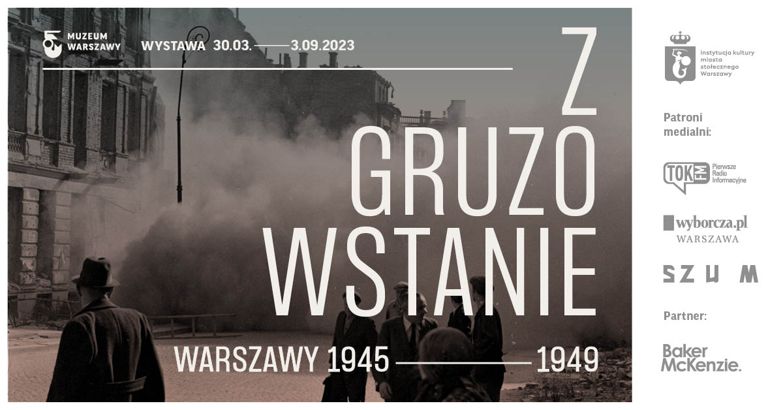
Warsaw has risen from rubble. Indeed—rubble was the basic building material, and working amidst the ruins was the stuff of life. Reconstruction was a complex process which required a huge amount of time and labour. It affected Warsaw’s architecture as well as its cityscape. It also had an effect on the social and economic relations that were being rebuilt anew after the war. Warsaw 1945-1949: Rising from Rubble exhibition offers a new perspective on the myth of the postwar reconstruction of the Polish capital city and one of the most interesting pages in its history. It opens already on 30 March.

The reconstruction phenomenon
The exhibition presents in a novel way a unique character of the city being rebuilt thanks to a collective effort. It follows the process of transforming ruins into rubble, and rubble into building material from which the Varsovians constructed their own future and the future of their city. The first years after the war were spent on removing the rubble and pulling down the ruins. Bricks and iron were being recovered and breeze-blocks were produced of concrete and rubble.
It is the first time that rubble constitutes the narrative core of an exhibition devoted to the reconstruction of Warsaw. We show fragments of sculptures and architecture, stove tiles and ceramics as well as materials used in the process of reconstruction: demolition bricks and rubble concrete. Photographs, graphic art, paintings, documents, maps, iconography as well as film newsreels and oral history video recordings place these exhibits in their historical context. Contemporary context is provided by artists such as Diana Lelonek whose work has been produced especially for this exhibition, or the sculpture by Monika Sosnowska made of concrete and reinforcing steel.

22 million cubic metres of rubble
What happened to ca 22 million cubic metres of rubble which covered almost the entire city after the war? The exhibition provides an answer to this question as well. In the first years of the reconstruction, the status of rubble was evolving. Initially, it was considered a waste material which ought to be removed. Next, it was regarded as a raw material to be recovered and used to produce new building materials. Ultimately, rubble acquired the status of a symbol of hard collective labour and a bright future for Warsaw and the entire country. This symbol, so eagerly used by the communist regime, is now given a chance to be interpreted anew.
“History of the reappraisal of rubble may serve as a direct reference to the contemporary debate on sustainable construction at the time of climate crisis, based on the recovery and recycling of materials,” points out Adam Przywara, the exhibition curator. “The 3R principle—namely reduce, reuse, recycle—was applied on a huge scale in postwar Warsaw,” he adds.

Over 500 artefacts in seven rooms
The exhibition narrative leads us through the first four years of Warsaw reconstruction. Artistic images of the ruins reflect the experiences of the people who returned to the war-torn capital first. Artists produced paintings, drawings and photographs. As we proceed to the next room, the ruins come to life, people lead their daily existence while first demolitions and cleaning-up actions begin. A large part of the cleaning-up was carried out by women from the Labour Brigades. Bricks grow to be invaluable. They are transported to Warsaw from Wrocław, Szczecin and other cities and towns of western Poland in its new postwar borders. Concrete rubble is invented and first attempts are soon made at putting it into use. Breeze blocks made of concrete and rubble were used while constructing the Koło II housing estate, or the edifice of today’s Ministry of Development and Technology at Trzech Krzyży Square.
The exhibition closes with a broader perspective on Warsaw’s cityscape which had undergone a major transformation, evident in the street grid and building development. The Warsaw Rising Mound as well as Moczydłowska or Szczęśliwicka Hills—all made of rubble—are now an organic part of the city, and yet their development still sparks off debates.
Aside from the original rubble and materials used during the city reconstruction, the exhibition also boasts works by artists such as Zofia Chomętowska, Jan Bułhak, Alfred Funkiewicz, Wojciech Fangor, Antoni Suchanek, as well as contemporary artists: Monika Sosnowska, Tymek Borowski or Diana Lelonek. They are complemented by archival documents, maps, fragments of film newsreels and memoirs.

The matriality of reconstuction
“Carrara marble in Rome, Portland limestone in London or ‘Paris stone’ in Paris—the histories of many European capitals can be deciphered by way of looking at the materials from which they were built,” says Adam Przywara, curator of the exhibition. “In the second half of the 20th century, Warsaw could also be distinguished by its unique material character: the city was reconstructed from rubble.”
“Today, production and circulation of building materials are key issues in both architecture and urban planning. The exhibition shows that the history of Warsaw reconstruction can provide inspiration for thinking about the future of architecture at the time of climate crisis. It also serves as a vital point of reference for contemporary artists and architects—the exhibition boasts works by the CENTRALA Studio, Diana Lelonek or Tymek Borowski,” adds the curator.

The stories about the city’s reconstruction in Museum of Warsaw
Warsaw’s postwar reconstruction is one of the most iconic moments in its history. Its traces can be found in practically each of the twenty-one Rooms that make up the Museum of Warsaw’s core exhibition. The exposition at the Heritage Interpretation Centre on 11/13 Brzozowa Street, right off the Old Town Market Square, focuses on the reconstruction of the capital city’s Old Town as well.
The reconstruction of Warsaw often comes up in the Museum of Warsaw program, e.g. on the occasion of the exhibition titled More Greenery! The Projects of Alina Scholtz and the publication devoted to the designer. In 2022, the topic of reconstruction turned out to be particularly up-to-date in the context of Russian aggression on Ukraine. The architect and artist Petro Vladimirov addressed it in his project titled Ukraine Reconstruction Office which can be viewed in the Room of Change at the Museum of Warsaw until 2 July 2023.
The year 2023 marks a symbolic 70th anniversary of Warsaw’s Old Town reconstruction. As part of the family celebration, the Museum of Warsaw and other institutions located in the vicinity of the Old Town Market Square will invite the residents to concerts, outdoor performances, a parade, a dance party, unveiling mysteries with conservation officers and numerous walks, lectures and urban games. Unique archival materials from the time of the reconstruction will be shown in the form of projections available for viewing at the Old Town Market Square.
Unveiling of a mural by Paulina Włostowska in the Room of Change will also be part of the celebration. The work will refer to Wojciech Fangor’s painting titled Kucie kos [Forging scythes] from 1954 which can be seen in the Museum of Warsaw’s core exhibition.

Accompanying program and accessibility
The exhibition will be accompanied by a rich program of events: guided tours, workshops, walks and bike tours.
Guided tours will be held every Sunday at 4PM, including curator guided tours with Adam Przywara on 2 April (translated to Polish Sign Language) and on 6 August. We will also invite our visitors to guided tours with our guests: Jarosław Trybuś (16 April), CENTRALA Studio—Małgorzata Kuciewicz and Simone De Iacobis (23 April), Sylwia Chutnik (14 May), Petro Vladimirov (guided tour in Ukrainian, 21 May), Grzegorz Mika (28 May), Agnieszka Szewczyk (4 June) and the BRDA Foundation—Zofia Jaworowska and Petro Vladimirov (18 June).
27 May will be a special date in our calendar, featuring lectures, debates and a walk in the footsteps of ruderal plant species with Urszula Zajączkowska. The day will end with a screening at the Syrena Cinema inaugurating a Film Week curated by Tomasz Kolankiewicz.
In June, Adam Przywara will guide a bike tour in the footsteps of the architecture and cityscapes of the early reconstruction period. On our route, we will visit buildings constructed with concrete and rubble on Pole Mokotowskie, the Ministry of Development and Technology at Trzech Krzyży Square, Jazdów and the Warsaw Rising Mound.
For people with intellectual disabilities and on the autism spectrum, plain language content and an exhibition guide will be available. Tactile graphics of selected objects with audio descriptions as well as texts in enlarged print and in the Braille alphabet will be created. Inclusive educational activities will be carried out in cooperation with experts (‘Wielozmysły’ Accessible Visual Culture Foundation, SYNAPSIS Foundation) and target groups (school in Laski and Inclusive School Complex No. 105 in Warsaw).

Adam Przywara – historian and scholar of architecture. In 2022, he obtained PhD from the University of Manchester for a dissertation devoted to the historical investigation of the materiality of ruins in the postwar reconstruction of Warsaw. Currently he is associated with the Université de Fribourg. Adam was a fellow at the Bauhaus Foundation in Dessau (2018) and at the Deutsches Historisches Institut Warschau (2020). He curated the exhibition titled See You After the Revolution! at the Arsenal Gallery in Białystok (2019). His research interests focus on the changes in the materiality of the 20th-century architecture, as well as the circular economy in both contemporary and historic construction.

The exhibition Warsaw 1945-1949: Rising from Rubble will be available for viewing from 30 March until 3 September 2023 at the Museum of Warsaw, 32 Old Town Market Square. The Museum is open on Tuesdays, Wednesdays and Fridays from 9AM till 5PM, on Thursdays from 9AM till 7PM, and on Saturdays and Sundays from 11AM till 6PM. Tickets: 20PLN/15PLN. On Thursdays admission is free.

For more information about the exhibition and the accompanying program, please visit: www.muzeumwarszawy.pl/en/wystawa/warsaw-1945-1949-rising-from-rubble/

COLOPHONE

curator Adam Przywara
cooperation Katarzyna Jolanta Górska
exhibition design Studio Okuljar Architekt*innen SIA
production Marta Galewska, Katarzyna Jolanta Górska
exhibition graphin design Alina Rybacka-Gruszczyńska
poster and promotional materials graphic design Anna Światłowska
maps Karolina Pietrzyk
photographs Diana Lelonek, Antonina Gugała
editing and proofreading Urszula Drabińska
production team Ksenia Góreczna, Paweł Grochowalski, Krzysztof Hernik, Piotr Lipiński, Artur Miniewicz, Katarzyna Radecka, Adam Rogowski, Leszek Sokołowski, Mariusz Stawski, Piotr Wójtowicz; Studio Robot
multimedia Piotr Szatyłowicz
conservation officers Robert Kołodziejski, Piotr Popławski
digitalisation Mikołaj Kalina
external loans Janusz Kurczak
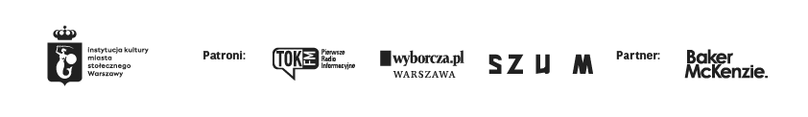
internal loans Tomasz Lewandowski, Małgorzata Oliwińska, Zuzanna Sieroszewska-Rolewicz, Filip Żelewski
accessibility Katarzyna Szafrańska
ETR and plain language Aleksandra Sztajerwald, Beata Strzelczyk
accompanying program Wanda Kaczor, Marcin Matuszewski, Karolina Iwańczyk
communications and marketing Joanna Andruszko, Melissa Czaplicka, Matylda Dobrowolska, Agata Fijałkowska, Daniel Karwowski, Aleksandra Koszalska, Anna Ładna, Aleksandra Migacz, Milena Paszkowska, Jowita Purzycka, Filip Wielechowski-Olszak
cooperation with research in the Museum of Warsaw collection
Karolina Ziębińska-Lewandowska, Jarosław Trybuś, Katarzyna Reszka
archeology: Zbigniew Polak, Ewelina Więcek, Zuzanna Różańska-Tuta
paintings and graphic art: Jacek Bochiński, Zofia Rojek
photography: Piotr Głogowski, Anna Topolska
architecture: Ewa Perlińska-Kobierzyńska
archive of documents: Rafał Radziwonka, Aneta Matuszewska
historic keepsakes: Monika Siwińska
private collections Maria Buko i Adam Przywara

Press contact:
Aleksandra Migacz
Museum of Warsaw
+48 22 277 43 45, +48 723 249 094
aleksandra.migacz@muzeumwarszawy.pl
Press materials:
www.muzeumwarszawy.pl/dla-mediow

