2024 Night of Photography

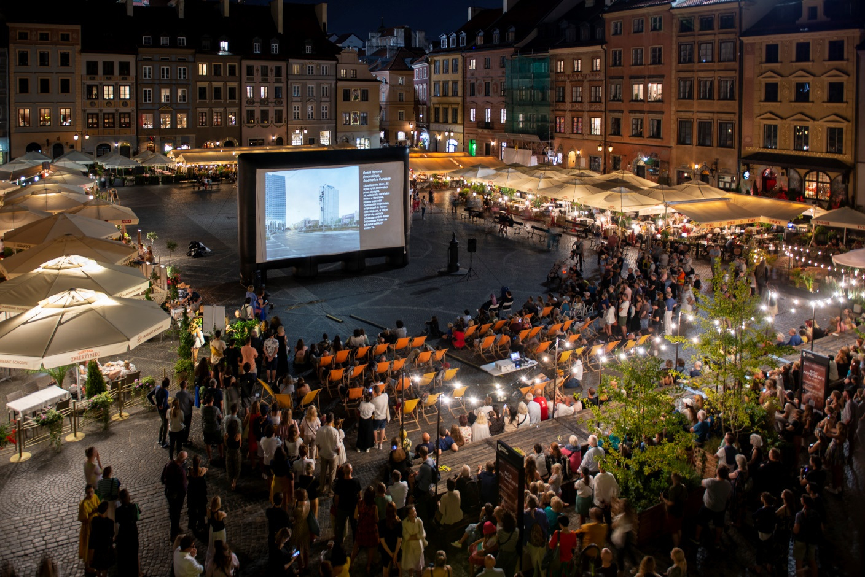
Night of Photography 2023, photo: Jarosław Barański

Museum of Warsaw Centre for Photography invites you to the second edition of the Warsaw Night of Photography which refers to similar events organized in other European cities. The second Night of Photography will be held in the Old and New Towns on 7 July 2024.
From 9PM to 11:30PM, we will be able to see a selection of works by photographers from Poland and abroad on large-scale outdoor projections located at several points in the Old Town. Some shows will be site-specific, taking into account the architecture and characteristic features of the Old Town locations. There will be projections on buildings, among other things.
During this year’s Night of Photography, guests will see both archival photographs and the latest ones, recognized at international festivals. Among them will be photographs from the Museum of Warsaw collection, showing the transformations of the Old and New Town areas, as well as works by the winners of the second edition of the photography competition, presented for the first time. The theme of the competition, “A City to Live In,” touched upon various aspects of housing in Warsaw.
We will also see a selection of Filip Springer’s photos taken as part of the Snapshots. Photographic Archive of Revitalization project. One of the projections, organized in collaboration with the Polish Women Photographers association, will be dedicated to Polish female photographers.
A highlight of this year’s edition of the Night of Photography will be a display of works by members of the famous Magnum photographic agency—Susan Meiselas, Bieke Depoorter, and Harry Gruyaert. Just like last year, we will also show a selection of photographs from the Rencontres d’Arles festival—the largest and oldest European festival dedicated to this art form.
Before the screenings start, at 7:30PM, there will be a meeting dedicated to the book titled Polscy fotografowie, krytycy i teoretycy o fotografii 1839–1989. Antologia [Polish Photographers, Critics, and Theorists on Photography 1839–1989. An Anthology] with its authors: Witold Kanicki, Dorota Łuczak, and Maciej Szymanowicz.

- Museum of Warsaw, Lapidarium, 40 Old Town Market Square
7.30PM – Meeting with Witold Kanicki, Dorota Łuczak and Maciej Szymanowicz about the book Polscy fotografowie, krytycy i teoretycy o fotografii 1839–1989. Antologia [Polish Photographers, Critics, and Theorists on Photography 1839–1989. An Anthology]
A conversation with the authors of the volume who are all associated with the Magdalena Abakanowicz University of Fine Arts in Poznań and who made an effort to collect all texts on photography written in Poland from the moment of the invention of this medium until the end of the People’s Republic of Poland.

9.15PM–11.30PM – Screenings of Return to Reason by Man Ray
Return to Reason is the title of the first legendary avant-garde film by Man Ray. On the 100th anniversary of its premiere, four of the director’s works—Return to Reason (1923), Emak Bakia (1926), The Starfish (1928), and The Mysteries of the Chateau of Dice (1929) – have been digitally restored and paired with music by the founders of the band Sqürl (Jim Jarmusch, Carter Logan).
The presented film is based on photography, photograms, and other visual experiments of the avant-garde master. It is a blend of experimental cinema, steeped in surrealism and Dadaism, full of visual surprises, geometric twists, and refined symbolism, accompanied by an unsettling, hypnotic, modern soundtrack.
Duration: 70 min (screenings at 9.15PM and 10.30PM).

- Museum of Warsaw, 28–42 Old Town Market Square
9PM – Welcome, invitation to the shows at other locations, handing in diploma to the laureate of “A City to Live in” competition.
9.15PM – Presentation of works of the laureates of “A City to Live in” competition.
The jury: photographer and researcher Karolina Gembara, writer and photographer Filip Springer, visual artist Szymon Rogiński, sociologist Justyna Orchowska and historian of art and photography, director of the Museum of Warsaw Dr Karolina Ziębińska selected seven projects that touch upon the topic of housing in Warsaw in the most interesting manner and from the most engaging perspectives—from social and communal (public) to private and personal.
The jury recognized the works by both debutants: Viktoria Adamova, Zbigniew Brzozowski, Krystian Furman, Anita Walczewska, and more recognized names: Sayam Ghosh, Anna Hornik, Damian Lemański.
“A City to Live in” photographic competition was organized by the Museum of Warsaw Centre for Photography.

9.30PM–11.30PM – Presentation of a selection of works by the photographers from the Magnum agency
A selection of works by three Magnum photographers: Harry Gruyaert, Susan Meiselas and Bieke Depoorter*
- Harry Gruyaert was born in Belgium in 1941, where he studied photography and film. In the early 1960s in Paris, he began photographing in colour, which continues to play a significant role in his work. In the late 1970s, he made numerous trips, including to the United States, India, Egypt, Japan, and Morocco. In 1982, he joined the Magnum agency. During the show, we will see a set of photographs taken by him in 1982 in the United States on route from Los Angeles to Las Vegas.
- Susan Meiselas, born in 1948 in the United States, completed her artistic education at Harvard University. She gained fame for her long-term projects which drew attention to the issues faced by minorities and conflicts overlooked by the global public opinion. She joined the Magnum agency in 1976 and is considered one of the first politically engaged photographers. A photograph she took during the uprising in Nicaragua became an international symbol of revolution and resistance against oppressive systems. During the Night of Photography, we will present a selection of works from the Prince Street Girls series, created in New York from 1978 to 1979.
- Bieke Depoorter was born in 1986 in Belgium. In 2009, she obtained a Master’s degree in Photography from the Royal Academy of Fine Arts in Ghent. Three years later, she was nominated for the Magnum agency, becoming a full member in 2016. Her artistic practice is rooted in the relationships she builds with her subjects. These relationships often start with chance encounters, and the project’s direction is determined by the development of these connections. In her works, she blends documentary with fiction, breaking traditional approaches to reportage. During the show at the Old Town Market Square, we will see a series of photographs from her 2015 Sète #15 project which offers a nocturnal, somewhat dreamlike vision of the seaside French town of Sète.

The shows will be looped.
* During the show, there will be scenes containing nudity. Please take this into consideration, especially if you are planning to attend with younger individuals or those sensitive to such content.

3. Polish Professional Photographers Union [Związek Polskich Artystów Fotografików (ZPAF)], 8 Castle Square
9PM–11.30PM – Presentation of works by the laureates of „A City to Live in” competition and photographs by Filip Springer

Presentation of works by the laureates of „A City to Live in” competition
Works by the laureates of “A City to Live in” photographic competition was organized by the Museum of Warsaw Centre for Photography touch upon various aspects of the topic of housing in Warsaw—from social and common (public) to private and personal. The jury recognized the works by both debutants: Viktoria Adamova, Zbigniew Brzozowski, Krystian Furman, Anita Walczewska, and more recognized names: Sayam Ghosh, Anna Hornik, Damian Lemański.
Presentation of Filip Springer’s photos taken as part of the Snapshots. Photographic Archive of Revitalization project
Filip Springer, co-author and curator of the project Snapshots. Photographic Archive of Revitalisation spent almost a year on his bike, touring the revitalised area on the right bank of the Vistula river in Warsaw and trying to capture with his camera the symptoms of the current and future transformations. He watches the architecture and nature, particularly trees, whose fate often serves as a good indicator of the surrounding changes. One of the first presentations of photographs taken by Springer as part of the Snapshots projects will take place on the Night of Photography.
The shows will be looped.

4. Lengrenówka – Museum of Caricature studio, 6/8A Brzozowa St.
9PM–11.30PM – Presentation of photos from the rich Museum of Warsaw collection
• Two different perspectives on the Warsaw Uprising—a montage of works by professional photographer and photojournalist Sylwester "Kris" Braun and painter Ewa Faryaszewska, a student at the Warsaw Academy of Fine Arts.
• A montage of photographs showing the transformations of the Old and New Town areas over more than 160 years. This will include works by well-known and acclaimed photographers as well as amateur and non-professional works.
The shows will be looped.
5. Sto Pociech Foundation, 20/24A Freta St.
9PM–11.00PM – Presentation of a selection of photographs from this year’s Night of the Year edition of the Rencontres d’Arles festival
Rencontres de la photographie is Europe’s largest and oldest photography festival, held annually in Provence. During the Night of the Year, a selection of the best photographic projects of the past twelve months is presented there. Courtesy of the festival, the residents of Warsaw will have the opportunity to see a selection of photographs straight from Arles just one day later than the festival participants.
The show will be looped.

6. Alina Foundation, 31/33 Brzozowa St
9PM–11.30PM – Night of Photography & Polish Women Photographers
Polish Women Photographers is a space for women and non-binary people for whom self-realisation and the need to speak out on important social issues and artistic expression through the medium of photography is important. In its activities, the association focuses on the promotion of Polish women photographers, taking care to maintain parity within the photographic community. During the Night of Photography, the works by four female documentary photographers will be presented on screen at the Alina Foundation—Alina Szapocznikow’s former studio. The women photographers are:
- Anna Hartman who uses photography to take the side of those who transcend conservative cultural norms. She profiles people who face prejudice, intolerance and even hostility from those around them. Her work is guided by the idea that to know is to understand and accept.
- Małgorzata Adamczyk, who has been travelling through small towns for the past five years, trying to capture the stories of the people who live there. Her project titled Friendship was awarded the Grand Press Photo in the People category in 2021.
- Małgorzata Smieszek, whose work encourages reflection on various aspects of life, focusing mainly on existential problems related to loneliness, freedom, fear of the future or the search for meaning in life.
- Marzena Hans, whose photographs address equality issues and relate to the representation of women in the contemporary world.
The shows will be looped.

COMPETITION
During this year’s Night of Photography, we will see the works of seven laureates of “A City to Live in” photographic competition organized by the Centre of Photography. This year’s competition entries explore various aspects of housing in Warsaw, ranging from social and communal (public) to private and personal. We will see both documentary and creative works, bold visions as well as intervention projects.
The competition was open to both amateurs and individuals with a documented portfolio, as well as to associated collectives. Awards were granted in two categories.
The works of the laureates, which will be presented during the Night of Photography on 7 July, were selected by a five-person jury consisting of:
Karolina Ziębińska – art historian (PhD) and curator of exhibitions, including projects such as Documentalists: Polish Women Photographers of the 20th Century (2008), the retrospective of Dora Maar (2019), and Moi Ver exhibition which was available for viewing at the Museum of Warsaw earlier this year. For many years, Karolina was associated with Zachęta National Gallery of Art. She is a co-founder of the Archaeology of Photography Foundation, dedicated to the protection and dissemination of the collections of leading Polish photographers.
Filip Springer – author of books on architecture and landscape, photo series and podcasts. Curator of the project Snapshots. Photographic Archive of Revitalisation organised by the Museum of Warsaw. Program director of the InstytutR Foundation, co-founder of the School of Ecopoetics and the po Drodze [en route] Festival.
Szymon Rogiński – visual artist, photographer and VR creator. His works are held in many collections and have been exhibited in museums and galleries all across the globe. Szymon is particularly inspired by road movies, pop culture and his home country—both the stereotypes and phantasms associated with it. He reaches for post-apocalyptic scenarios, draws on man-altered landscapes and specialises in nocturnes. He is currently exploring creative applications of photogrammetry and virtual reality. He lives and works in Warsaw.
Justyna Orchowska – sociologist and assistant professor at the Centre for European Regional and Local Studies (EUROREG) at the University of Warsaw. In her academic work, she focuses on the sociology of the city and housing. She is the author and co-author of many expert publications, including the book titled Białe plamy. Mieszkańcy Warszawy o usługach publicznych [White Spots. What the Residents of Warsaw Think About Public Services, 2022]. Justyna has been associated with the Miasto jest Nasze Association since 2014.
Karolina Gembara – photographer, researcher and PhD student at the Krzysztof Kieślowski Film School in Katowice. Her work focuses on the issues related to home, migration and care, as well as local political themes. In recent years, Karolina has initiated and implemented several projects involving people with refugee experience. She is a member of Sputnik Photos and collaborates with the Public Protest Archive, where she initiates art and research projects and edits the Strike Gazette.

Event program: https://muzeumwarszawy.pl/wydarzenia/noc-fotografii-2024/

Contact for the media:
Nela Sobieszczańska
Muzeum Warszawy
+48 502 244 911
nela.sobieszczanska@muzeumwarszawy.pl

Materials for the media: www.muzeumwarszawy.pl/dla-mediow

