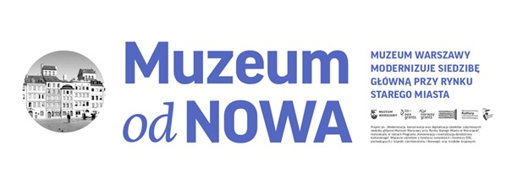
27 April 2017

Great countdown to the opening of the Museum of Warsaw

The renovation of the Museum of Warsaw which commenced in 2014 has just been completed. The ‘Restored’ project included modernisation, conservation and digitisation of museum objects and of 11 historic burgher houses, the Museum Principal Seat, as well as creating the new core exhibition titled „The Things of Warsaw.” The completion of works will be marked by a formal opening of the Museum Principal Seat on 26-28 May 2017, a two-day open event to be held at the Old Town Market Square. That weekend attractions will abound – there will be screenings and illuminations on the tenement buildings’ facades, art installation at the Square and concert of Sinfonia Varsovia.

- I am most glad that both the local residents and guests to Warsaw will be offered a chance to engage with our city’s cultural heritage and history presented in a new, inimitable exposition, thanks to which they will be able to take a tour through several centuries of Warsaw’s history. The objects presented at the exhibition, as well as their stories, will help our guests identify their own stories with the history of the city and the people who, like us right now, made an impact on the city’s character – says Hanna Gronkiewicz-Waltz, Mayor of the City of Warsaw.

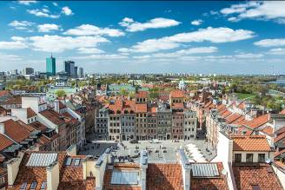
- The Museum of Warsaw is the city’s cultural institution. We are just about to open a new chapter in our over 80 years old history. The return to the Museum’s Principal Seat, linked with a grand opening of the new exhibition is a perfect culmination of the long and intensive work on the part of the Museum’s entire team – adds Ewa Nekanda-Trepka, Director of the Museum of Warsaw.
For the first time since the postwar reconstruction, a thorough renovation of the Museum burgher houses has been conducted as part of the ‘Restored’ Project. The renovation included the basements (which were renovated before), restoring the façade colour scheme as indicated in the 1950s by the conservation officers as well as architectural detail. All works, both on the exterior and the interior, were planned and carried out in order to provide – while preserving the original layout – the best possible functional setup with regard to the buildings’ operation as a museum. The methods and technologies applied in the course of the renovation process were not to tamper with precious interiors but rather to restore them to their former splendor by way of conservation work. The facilities were also adapted to accommodate the needs of persons with disabilities of various types.

Total cost of the Project amounts to over 64 million PLN, including 46 million of the investment grant from the City of Warsaw Municipal Office. Over 18 million came from the Norwegian Financial Mechanism and the European Economic Area Financial Mechanism.

“The Things of Warsaw” core exhibition comprises over 7,000 objects assorted in 21 topical rooms. Amongst them, there are both artworks and utility items, all originals. In May, the first part of the exhibition will be opened to the public, namely 8 rooms and the accompanying sections (“Warsaw Data” and “History of the Burgher Houses”), as well as an educational program. Our visitors will be able to use a café, bookstore, library with a Varsavianist Reading-Room, cinema, as well as an observation deck. The premiere of the remaining part of the exhibition and a temporary exhibition have been planned for the second half of the year.

- The Museum, our city’s treasure, will bring to you only the original “Things of Warsaw”. We do hope that – thanks to our collection and the ambience of the burgher houses’ interior, all those who visit us will start to appreciate what is happening around them and to better understand the surrounding reality – sums up Ewa Nekanda-Trepka, Director of the Museum of Warsaw.

To celebrate the Project drawing to an end, we invite you to a two-day celebration at the Old Town Market Square. Already on 26-28 may, very many attractions await the visitors: night-time screenings, artistic illumination on tenement buildings and concert of Sinfonia Varsovia. There will also be a surprise for all those who visit the Old Town that weekend. “The Museum will step out” and present a fragment of “The Things of Warsaw” exhibition at the Old Town Market Square. The Platige Image team stands behind the multi-layered installation. The celebrations will start on Friday, 26 May at 8PM. For a detailed programme of the incoming events, please go to: http://muzeumwarszawy.pl

Addenda:
- Information on the “Restore” shop
- “Making of” - a trailer to the core exhibition
- Program of the grand opening 26-28 May 2017
- Animation of selected stories of objects from the Room of Postcards
- Information on volunteering

Contact with media:
Dagmara Mazurek, Public Relations Specialist,
tel.: 883 946 252, tel. (+48) 22 596 67 62
e-mail: dagmara.mazurek@muzeumwarszawy.pl
Agnieszka Kłąb
Deputy Press Officer
of the City of Warsaw Municipal Office
Tel. 22 44 333 82
519-066-077 | aklab@um.warszawa.pl

The Museum of Warsaw was established in 1936. Its Principal Seat is located at the Old Town Market Square, in 11 historic burgher houses which were entered in the list of the UNESCO World Heritage. The Museum of Warsaw also runs 9 external branches, including The Museum of Warsaw Praga, the Heritage Interpretation Centre and the Museum of Printing.

For the past 80 years, the Museum of Warsaw’s mission was to collect, store and develop the objects relating to Warsaw, and to make them available to general public. By way of producing exhibitions, conducting research, publishing, educating and spreading culture, the Museum has been accompanying its visitors in the process of discovering the phenomenon of Warsaw.

In the years 2014-2017, the ‘Restore’ Project has involved modernisation, conservation and digitisation of the historic museum objects, as well as creating the core exhibition. The formal opening of the newly refurbished Museum of Warsaw on 26-28 May 2017 is a culminating point of the Project.

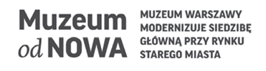


The Project titled “Modernization, Conservation and Digitisation of Historical Facilities of the Museum of Warsaw’s Principal Seat at the Old Town Market Square in Warsaw” was realised as part of “The Conservation and Revitalisation of Cultural Heritage” programme area. The support was provided by the Norwegian Funds and the EEA Funds from Iceland, Liechtenstein and Norway, as well as local resources.
.

