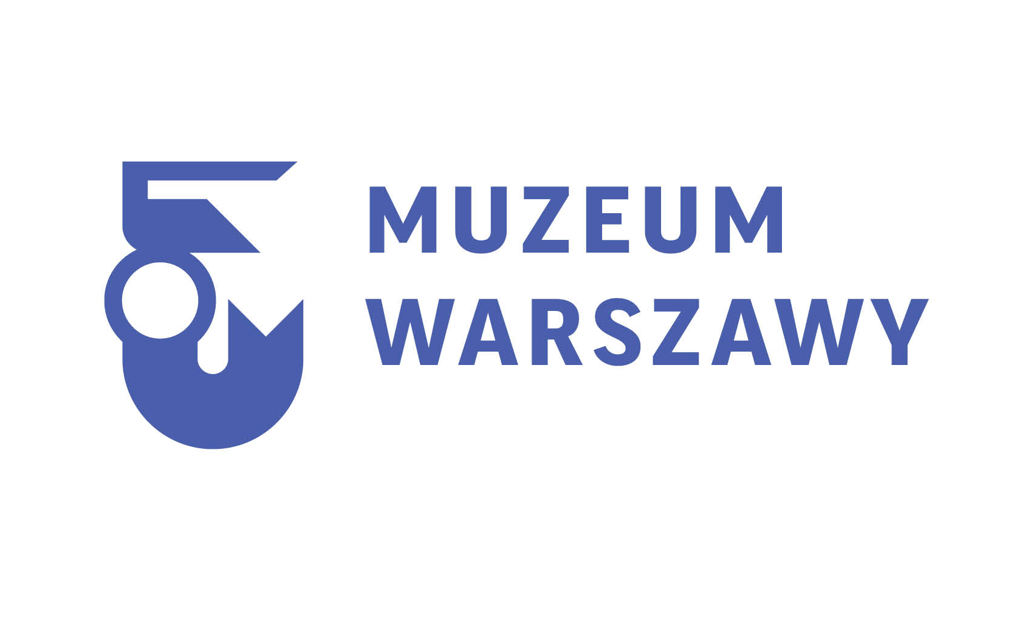
Already in May 2017, after years of intensive restoration works, the Museum of Warsaw will open its door to the general public again. In 11 modernised tenement houses at 28-42 Old Town Market Square, a new core exhibition, temporary exhibitions, a diverse program of events, meetings, workshops and tours will await the visitors, who will also be able to enjoy the Museum’s café, library, cinema and observation point. The grand opening of the Museum of Warsaw has been planned as a two-day, open-to-public artistic event which will take place both inside and outside the Museum, at the Old Town Market Square. We look forward to seeing you there on the last weekend of May (26-28 May).

“The project of restoration and conservation of the Museum of Warsaw principal seat located at the Old Town Market Square - currently in its final stages - is vital for our city, its inhabitants and guests. The completion of this gigantic cultural endeavour means that soon we will be able to dive into the cultural heritage and history of Warsaw as presented in a brand new exhibition housed at the revitalised tenement houses in the Old Town, one of the main spots on the cultural and tourist map of the capital city,” says Hanna Gronkiewicz-Waltz, Mayor of the City of Warsaw.

Along with the re-opening its principal seat, the Museum of Warsaw is entering a new era of its 80-year-old history. The Museum houses over 300,000 objects which form the largest collection of items relating to Warsaw history. Its role and mission is not merely retelling its story, but also building a sense of connection with its symbols, tradition and the past generations of residents.

The new exhibition The Things of Warsaw, along with its accompanying sections: The Warsaw Data, History of the Tenement Houses and the temporary exhibition, is spread over 5 floors of 11 restored tenement houses and constitutes the fruit of 4 years of intense work by the team of 32 curators, as well as the entire Museum team of employees.

“In the twenty-one Rooms the visitors will come across the Things – witnesses to and participants of the history of Warsaw. They serve as a pretext to tell the story of their owners and creators, breakthrough events and long-term processes. We do not present one history; we do not construct one narrative. While touring the eleven Old-Town tenement houses, each visitor is offered an opportunity to narrate – at their own pace and following their own route – their own history of Warsaw,” comments Jarosław Trybuś, Deputy Director for Content of the Museum of Warsaw, who led the team of curators working on the core exhibition concept.

The Things of Warsaw equals 7,352 objects located in 21 rooms. These are artworks as well as everyday objects – all original items. The visitors will have an option to tour the exhibition via an individually set route or choosing one of four original routes. The Museum invited eminent personalities whose lives and activities are closely related with the city to cooperate in mapping out the routes, i.a. Beata Tyszkiewicz, Jurek Owsiak, Jan Komasa, Professor Maria Poprzęcka. In May, a route mapped out by Bartosz Panek – a journalist and commentator at Polish Radio Two, laureate of, among others, the 2014 Prix Italia – will be opened. The route follows all the Rooms and the key items which the curators deem as particularly meaningful due to their origin, direct connection to the history of the city, uniqueness, or the person of its author or owner. The tour has also been prepared with people with vision or hearing impairment in mind. The premiere of the author routes is planned for October.

The accompanying sections of the core exhibition will be of vital importance: infographics of The Warsaw Data which will present – in an attractive and often baffling fashion – data pertaining to the city of Warsaw. They are aimed to inspire the visitors to seek answers to questions such as: to whom does Warsaw owe its growth? Who are and were the city inhabitants? How did they use to live? How do they live nowadays? What constitutes the city centre, where are its boundaries? History of the Tenenemt Houses, on the other hand, is a space where the visitors will be able to discover the stories of transformation of the historic buildings which now house the Museum as well as the most curious elements of their architecture.

Temporary exhibitions will be yet another important section of the Museum. The first, to be opened in May, will reveal to the general public the process of the making of the core exhibition – from the initial idea to the final selection of objects, the architectural project and its realisation. Its core elements will be new arrivals and objects which have undergone the conservation process as part of the tenement houses restoration project. The exhibition will refer to the very beginnings of today’s Museum of Warsaw existence – the pre-war activity of the Society of the History Enthusiasts and the Society for the Preservation of the Historic Monuments, as well as the post-war activity of the Historical Museum of the City of Warsaw. It will thus be not only the exhibition devoted the exhibition, but also the exhibition devoted to the Museum.

The Museum also developed a rich programme for children and adults, including tours of the Old Town, “Pop into the Museum” series of weekend workshops for families with children, workshops in drawing aimed at practice in perceptiveness and powers of observation. For those willing to broaden their knowledge on the objects displayed in the exhibition, the Museum of Warsaw published a book titled The Things of Warsaw (Rzeczy Warszawskie).

The Museum building has been made available for persons with mobility impairment on levels -1 and -2, level 0, and levels +1 and +2. The lifts were installed, alongside ramps and moving platforms. The work is in progress to make the remaining levels available for wheelchair users. The Museum will also be friendly for pets.

Currently, the project of the Museum of Warsaw modernisation is drawing to an end. The interiors are ready for welcoming visitors – all the details, both these dating back to the Museum reconstruction in 1953, and the historic ones such as 17th century wooden polychrome ceilings, details in hallways and murals. The works on the realisation of the first stage of the core exhibition are underway.

In May, the first part of the core exhibition will be opened. It will comprise 8 Rooms and the accompanying sections, as well as a temporary exhibition and the educational program. The visitors will be able to enjoy our café, bookstore, library with a reading room abound with the collection of Varsaviana, cinema and observation point. The premiere of the second part of the exhibition has been planned for October 2017.

The overall cost of the investment exceeds 64 million PLN. Over 18 million comes from the Norwegian Grant (The Norwegian Financial Mechanism and the European Economic Era Financial Mechanism), 46 million comes from the City of Warsaw investment donation.

Contact for the media:

Dagmara Mazurek, Public Relations Specialist,
Mobile: + 48 883 946 252, tel. (+48) 22 596 67 62
e-mail: dagmara.mazurek@muzeumwarszawy.pl
For the materials for the media please go to: www.muzeumwarszawy.pl/media/

In 2016, the Museum of Warsaw celebrated its 80th anniversary. Since its foundation in 1936, the Museum’s mission has been to collect, preserve, research and exhibit varsaviana. Over the years, it has acquired over 300 000 unique pieces, which is the largest collection of its kind in the world. Through numerous exhibitions, research, publishing as well as educational and cultural activities, the Museum has worked to help tourists and locals alike, explore the city of Warsaw and its unique history.
The Museum of Warsaw currently has 11 divisions around the city, with its main headquarters housed in neighboring tenement houses on the Old Town Market Square. In 1980, Warsaw’s Old Town was placed on the UNESCO list of World Heritage Sites. In the years 2014 to 2016, the Museum’s headquarters underwent extensive renovations, the Museum’s collection underwent conservation, was photographed and digitalized, and the concept for an entirely new core exhibition was created.
The Things of Warsaw exhibition showcases the Museum’s extraordinary collection with nearly 7 500 objects on display in 21 themed rooms. Each object tells its own story of Warsaw – the Museum helps explore the city through architectural details, photographs and postcards, souvenirs, clothing, and more. Alone, these items seem to be nothing more than memorabilia, together, they become an intricate story of an intricate, developing city. Visitors will be able to choose a variety of ways to navigate the exhibition, they will have the possibility of creating their own stories of Warsaw.

In May 2017, the Museum of Warsaw will be re-opened to the public – with its brand new core exhibition, in its brilliantly refurbished headquarters.



The project entitled “The Modernization, Conservation and Digitisation of Historical
Facilities of the Museum of Warsaw’s Principal Seat at the Old Market Square [Rynek
Starego Miasta] in Warsaw” benefits from support funding under the European
Economic Area Financial Mechanism and the Norwegian Financial Mechanism in “The
Conservation and Revitalisation of Cultural Heritage” programme area. The support is
provided by the Norwegian Funds and the EEA funds from Iceland, Liechtenstein and
Norway, as well as local resources.

