Testimonies from the Warsaw Ghetto. Opening of a new section of the Museum of Warsaw core exhibition on 17 April

Museum of Warsaw, opening: April 17, 2024
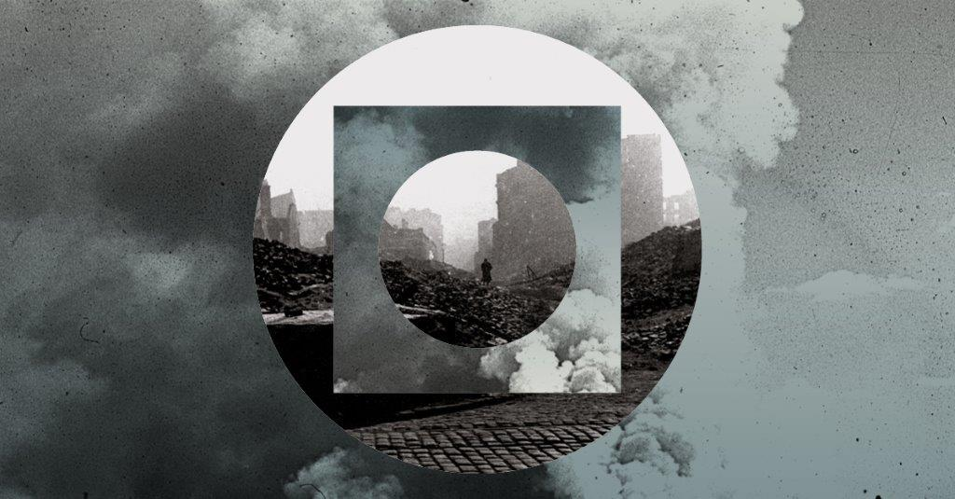 Graphic design: Anna Światłowska, based on photos by Rosemarie Lincke and Leonard Sempoliński from the collection of the Museum of Warsaw

On 17 April, as part of the commemoration of the 81th anniversary of the outbreak of the Warsaw Ghetto Uprising, a new section of the core exhibition will be opened at the Museum of Warsaw. The Room of Testimonies from the Warsaw Ghetto captures the moment of transformation from a buzzing Northern Quarter to a sea of rubble that Warsaw turned into in the course of the Second World War. In the exposition, two extreme perspectives will be juxtaposed – from inside the ghetto and from the “Aryan” side. Photographs taken by German soldiers from international archives will be displayed alongside pictures taken by residents of the ghetto and members of the resistance movement. Together with a few objects retrieved from beneath the ground, the photos will spin a moving tale about the creation of the ghetto, its operation, the uprising, and finally its liquidation and the legacy that lives on.

History of the ghetto as an integral part of the history of Warsaw
Testimonies from the Warsaw Ghetto exposition is an attempt at showing the unimaginable. It covers the period from the beginning of the German occupation and the delineation of the “area at risk of typhus” in Warsaw in spring 1940 to the commemoration of the fifth anniversary of the Warsaw Ghetto Uprising in 1948. The daily life of the ghetto is presented from various perspectives—soldiers and members of the resistance movement, women and men, amateurs and professionals. Not only do their photographs tell a universal story about the war, but they also allow for contact with wartime reality from different points of view and a look at postwar Warsaw. Objects recovered during archaeological digs, belonging to people from the pre-war Northern Quarter, are material vestiges of the life of a community that had inhabited the northern part of Warsaw for nearly 200 years. The exposition concludes with a film which also serves as the only source of light in the exhibition. The document recorded by a group of survivors right after the war shows the void left of the ghetto, turned into a rubble desert after the entire Jewish community had been annihilated, the void that has grown to become a symbol of their Holocaust.
“One cannot talk about the history of Warsaw, its destruction and reconstruction, without mentioning what happened in the Warsaw ghetto. The Museum of Warsaw is obliged to include in its core exhibition the community which before the war had constituted nearly one-third of the city’s total population, and from which only a few survived the wartime,” says Karolina Ziębińska, Museum of Warsaw director.

“The exposition is located at the place where the narrative on what exerted the strongest influence on the shape of today’s Warsaw begins. The borders of the ghetto kept shifting, penetrating the city centre, all the way to Zamkowy Square and the Old Town Market Square, reaching the buildings that today house the Museum of Warsaw. Even though the ghetto wall was ultimately moved, the history of the ghetto altered the centre of Warsaw forever,” says Anna Duńczyk-Szulc, exhibition curator and deputy director of the Museum of Warsaw.
”Area at risk of typhus”. Sealing off the Jewish Quarter
Prior to the outbreak of World War II, the Jewish community constituted 30% of the total population of Warsaw. The majority of Jews resided in the Northern Quarter. Nalewki, Chłodna or Krochmalna Streets, full of hustle and bustle, were the heart of the Jewish world with its unmatched level of diversity—social, religious, and political. Within just a few years, this world ceased to exist.
Delineated in the spring of 1940 by the German administration, by the autumn of the same year the “Seuchensperrgebiet”, or the “area at risk of typhus,” was separated from the rest of the city by a wall with barbed wire. Nearly 350,000 people were imprisoned in the Warsaw ghetto. The dramatic conditions meant that the Jewish community, both individually and collectively, had to face death on a daily basis.

The Warsaw Ghetto Uprising
The Great Liquidation Aktion began on 22 July 1942. Mass deportations to the death camp in Treblinka left the ghetto almost completely empty. In 1943, the area of the former Northern Quarter was razed to the ground. On 19 April 1943, at dawn, SS units entered the ghetto via the gate on Nalewki Street. The fighters took the Germans by surprise, shooting at them from the rooftops, attics or windows of buildings at the intersection of Nalewki, Gęsia, Zamenhofa and Miła Streets, and on Muranowski Square. Meanwhile, the civilians were hiding in pre-arranged bunkers. The Germans didn’t expect resistance Even though open combat lasted only several days, the ghetto residents resisted the Germans for a month. Unable to crush the resistance, the Germans razed the ghetto to the ground. Thousands of people were deported to Treblinka and to the camps in Majdanek, Poniatowa and Trawniki.
We, the Survivors
After the Uprising had been suppressed, the Germans began a systematic destruction of the entire ghetto area. As a result, the former Northern Quarter practically disappeared from the face of the earth. The ghetto was burned to the ground, and the entire Jewish community was annihilated. All that was left was the rubble, ruins, and an empty space in the northern section. In the exhibition, a film that is most likely the only surviving footage from that period will be shown to the public for the first time. A documentary titled Mir, lebngeblibene [We, the Survivors], shot shortly after the war, reveals the unimaginable—the staggering scale of a national disaster, after which the Jewish community strove to return to normal life in a socialist reality. The shots of a sea of rubble stretching to the horizon are accompanied by the prayer El Male Rachamim [God Full of Mercy], which obliges the survivors to remember those who are no longer present.
What was left of the Warsaw ghetto
After the liberation of Warsaw in 1945, the Warsaw ghetto did not disappear—the sea of rubble was a constant reminder of the committed crimes. The memory of those who had perished and of their suffering was not obliterated by a total destruction. The Warsaw Ghetto Uprising grew to become a vital element of the collective memory of the Holocaust, and remembering the ghetto fighters and civilian martyrs was an obligation of those who had survived. However, the initial hopes of the Jewish community to rebuild the Northern Quarter came to naught. In 1948, during the commemorative events on the fifth anniversary of the outbreak of the Warsaw Ghetto Uprising, the idea of reviving the Jewish district in Warsaw was abandoned, and the history of Polish Jews was thus severed. Soon, the State of Israel would be established and the sea of rubble left of the ghetto would turn into a new residential quarter, an area of new possibilities—the Muranów housing estate.
Scarcity of material traces
In postwar Muranów, built on the rubble of the ghetto, there are practically no material traces left of the once vibrant Jewish life. Objects now hidden deep underground are brought to light during archaeological digs. Search conducted in the area of the former ghetto for the Ringelblum Archive and the archive of the leftist-Zionist Bund party ended in failure. The few unearthed items bear witness to the daily life of the Jewish residents of Warsaw both before the war, during wartime and the Uprising. Some of the recovered documents, fragments of dishes, forks and buttons will be on display in the Room, alongside other visual testimonies of the life of the community that inhabited this part of Warsaw for nearly 200 years, of which only a few had survived.
The Room is located at the basement level—it will conclude the narrative on the city and its inhabitants during World War II. It will fill the gap—there is a scarcity of testimonies on Jewish life in other sections of the core exhibition. The exposition is based on the collections of the Warsaw Museum, the Jewish Historical Institute, the National Film Archive—Audiovisual Institute, and other institutions.

Anthology of Glances. The Warsaw Ghetto: Photographs and Films publication
In 2023, a publication titled Antologia spojrzeń. Getto warszawskie – fotografie i filmy [Anthology of Glances. The Warsaw Ghetto: Photographs and Films] by Anna Duńczyk-Szulc and Agnieszka Kajczyk came out as a harbinger of the new exposition. The album contains previously unpublished photographs from the Warsaw Ghetto Uprising, frames from what is most likely the only surviving film from the Uprising, recordings made by propaganda units and by amateurs, and photographs taken by soldiers, residents of the ghetto, and members of the resistance movement. The album includes a comprehensive selection of photographs and film frames taken in the Warsaw Ghetto and on its ruins in the years 1940-1948. The book is available for purchase at the Warsaw Museum bookstore at the Old Town Market Square.

Testimonies from the Warsaw Ghetto
Formal opening: 17 April 2024 at 6PM

The exhibition opening will be accompanied by a discussion with the curators Anna Duńczyk-Szulc and Aleksandra Sołtan-Lipska, and with Dr Agnieszka Kajczyk about the photographs and films from the Warsaw Ghetto that are featured in both the exhibition and the album Antologia spojrzeń. Getto warszawskie – fotografie i filmy [Anthology of Glances. The Warsaw Ghetto: Photographs and Films].

Curators: Anna Duńczyk-Szulc, Aleksandra Sołtan-Lipska
Consultant: Dr Agnieszka Kajczyk
Graphic design: Anna Światłowska
Exhibition design: Jan Libera
Partner of the exhibition: Emanuel Ringelblum Jewish Historical Institute

Testimonies from the Warsaw Ghetto exhibition will open on 17 April 2024 at the Museum of Warsaw, 42 Old Town Market Square. It will be available for viewing as part of the core exhibition at level —1. The core exhibition opening hours are as follows: Tuesday, Wednesday, Friday 9AM-5PM, Thursday 9AM-7PM, Saturday, Sunday 11AM-6PM. Ticket prices: 25PLN regular/18PLN reduced; on Thursdays admission to the Museum is free. To read more about the exhibition please go to: www.muzeumwarszawy.pl/en
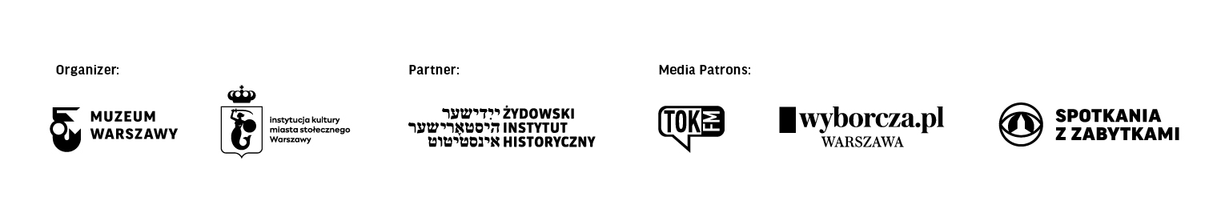
Biograms

Anna Duńczyk-Szulc – graduate of the Institute of Ethnology and Cultural Anthropology at the University of Warsaw. She is a co-curator of the permanent exhibition at the Jewish Historical Institute titled What We’ve Been Unable to Shout Out to the World, editor of the book Rozproszony kontakt. Fotografie z Archiwum Ringelbluma na nowo odczytane and a co-author of Antologia spojrzeń. Getto warszawskie – fotografie i filmy. Currently, she holds the post of the Museum of Warsaw Deputy Director.

Aleksandra Sołtan-Lipska – graduate of the Institute of History at the University of Warsaw. She is a co-curator of the core exhibition at the Museum of Warsaw, and the curator of the permanent exhibition dedicated to the history of commemorating the victims of the 1944 Warsaw Uprising, on display in the Hall of Remembrance at the Warsaw Insurgents’ Cemetery. Currently, she heads the Department of Research on the History of Warsaw and its collections.

Contact for the media:
Joanna Andruszko
Museum of Warsaw
+48 693 974 686
joanna.andruszko@muzeumwarszawy.pl

